LAB 1

From the previous adv tooling assign I didn’t exit the vm,,,,,,,NOW I exit from the ssh session and did vagrant ssh to reconnect  
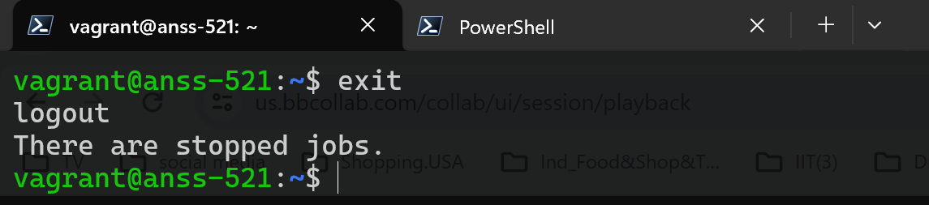

Again I typed exit and I got this:

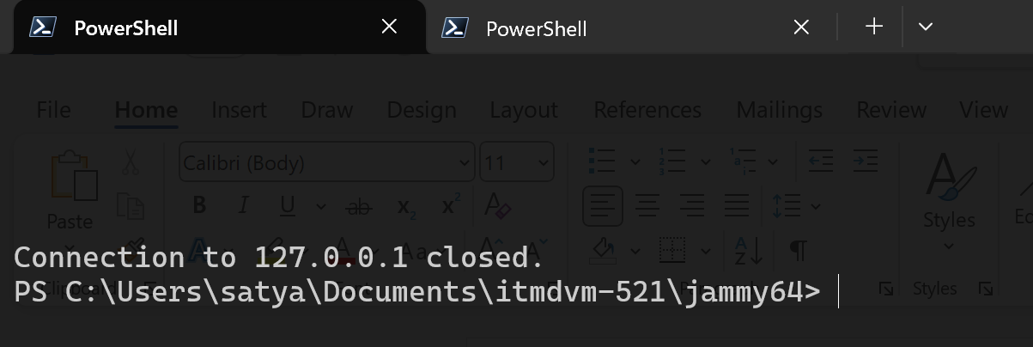

Then I did vagrant ssh to reconnect:

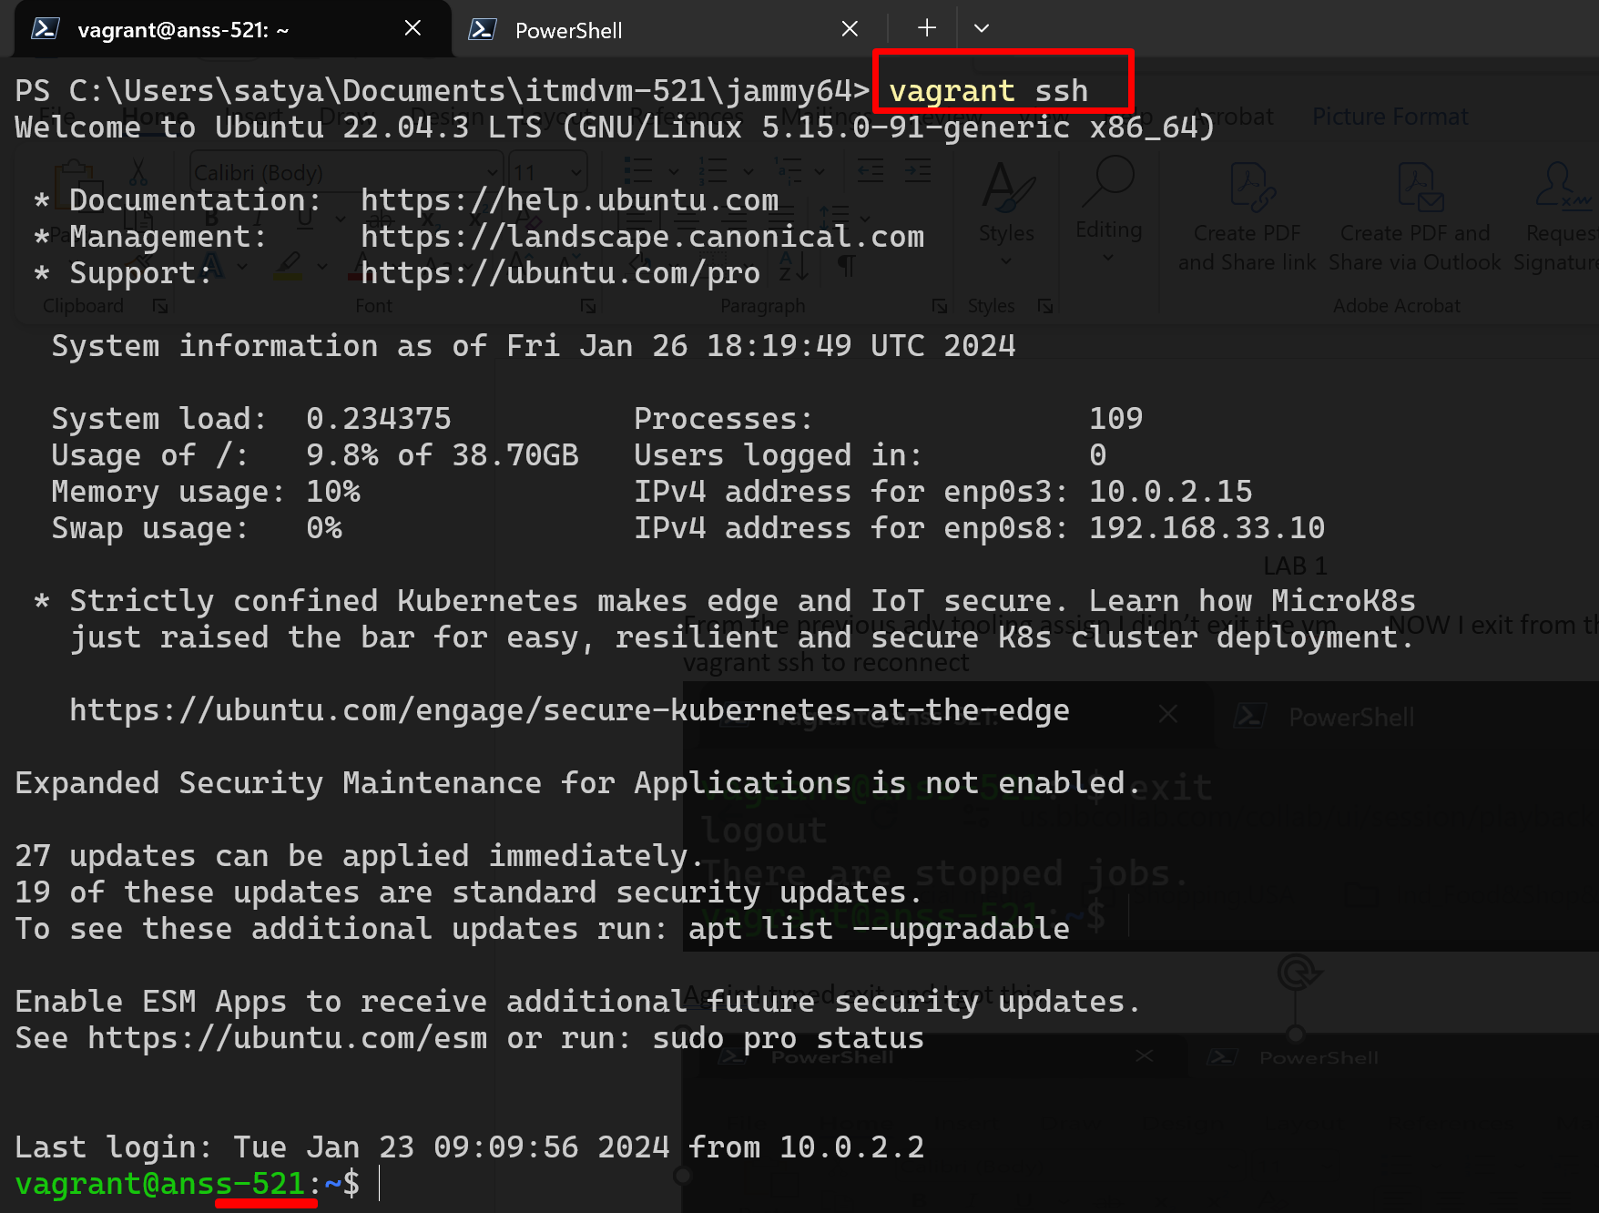

**STEP 1:**

I **cloned** the source code in to my vagrant box-ubuntu anss-521 with the command:

**git clone https://github.com/databricks/LearningSparkV2.git**

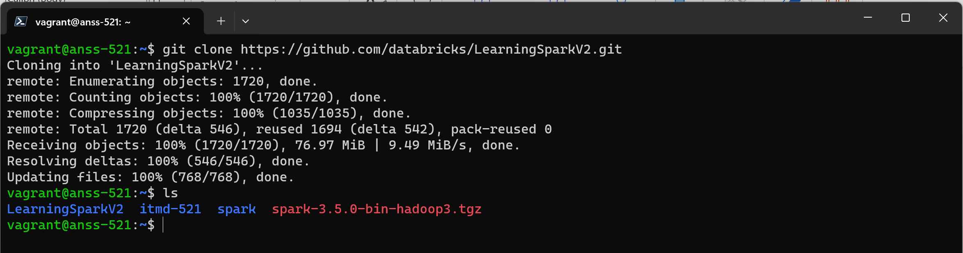

And then I went into spark-shell and did this. Went into spark directory and read this readme file.

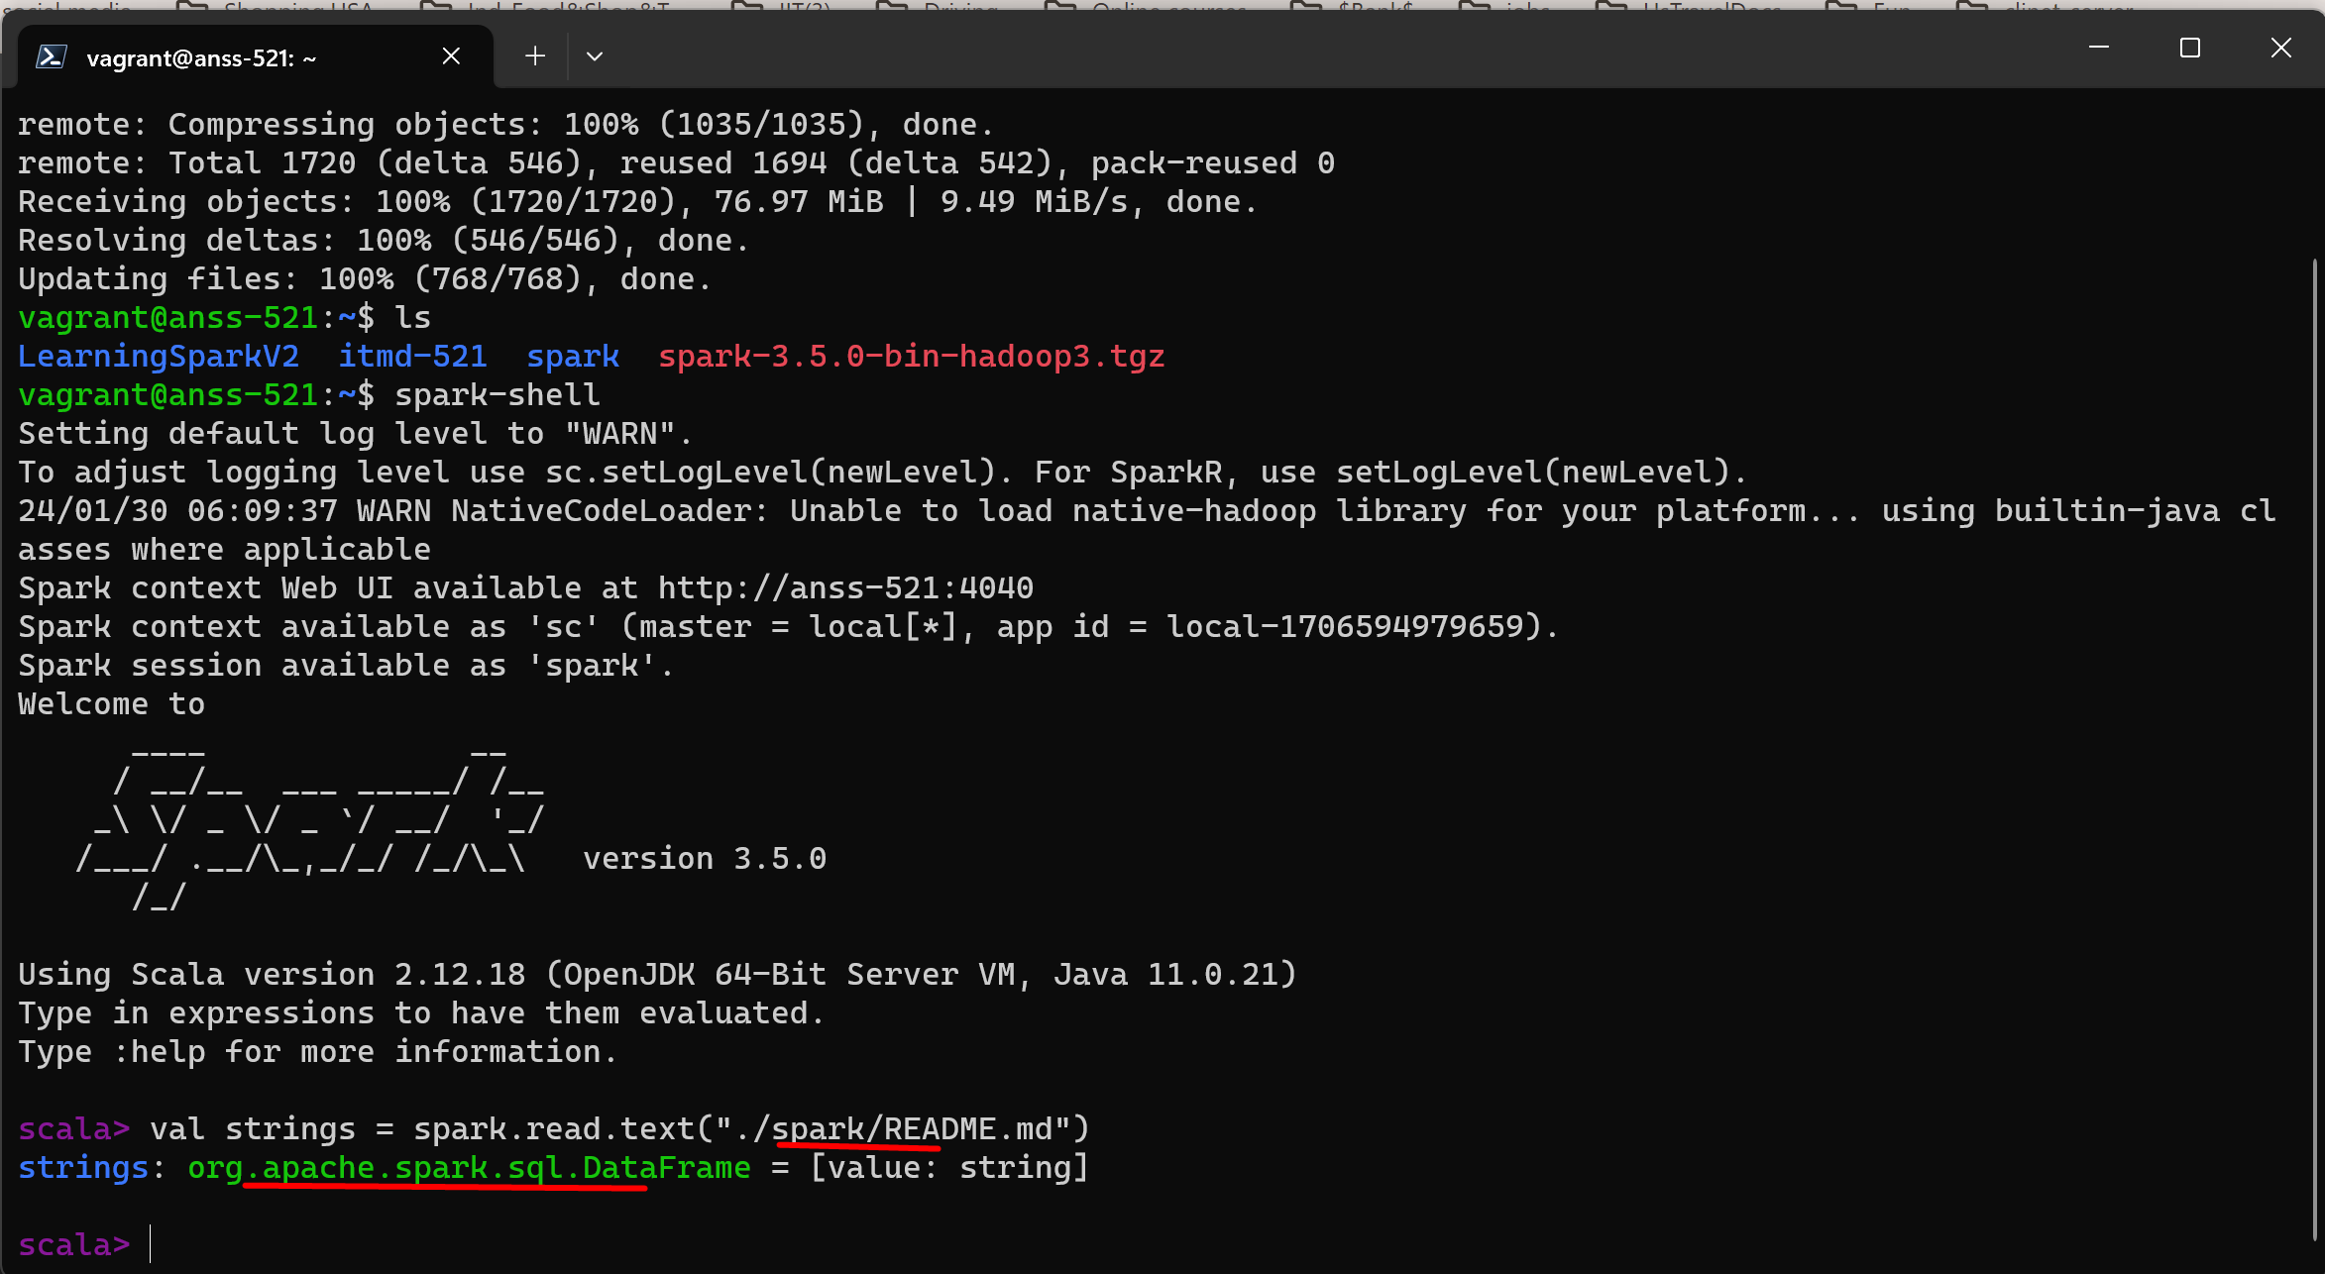

And then I pressed cntrlD to quit

I typed all the source code (python code) given by the prof in LearninSparksessionV2 in my vs code

Created a **folder labs under itmd-521** – **under labs another folder week-03**- added/dragged the downloaded screenshot **readme file under week-03 folder** – **under week-03 created a file called mnmcount.py and added codes step by step (3 to 4 lines of code)** and did commits(almost did 10 commits) bcoz prof asked not to copy paste the code all at once ,,he asked to write the code step by step and do the commits..he will see the commits history… refreshed in github……

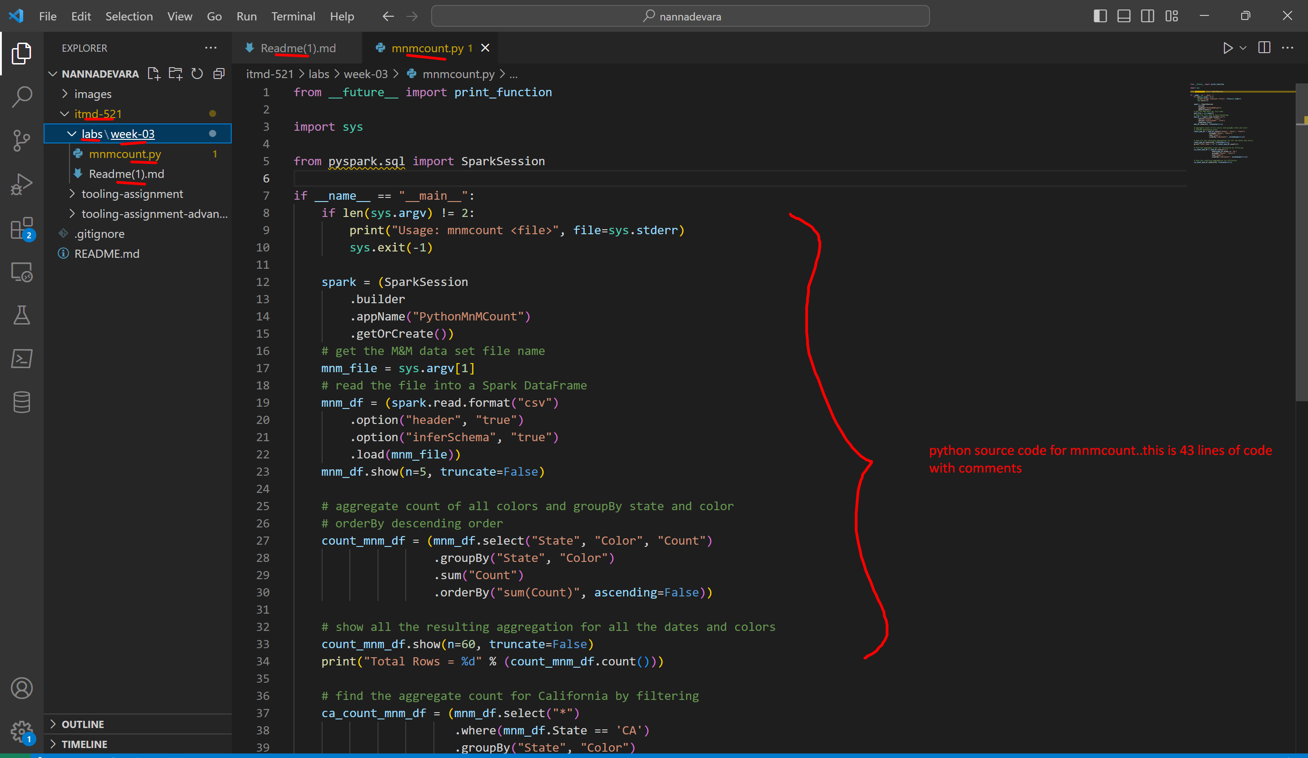

So to update the newly added folders (prev adv tool assig or this new folder labs week-03) do the git pull in our vagrant box anss-521 – go into the itmd-521 folder(where we cloned our private nannadevara repo) and go to nannadevara folder and do the git pull like this

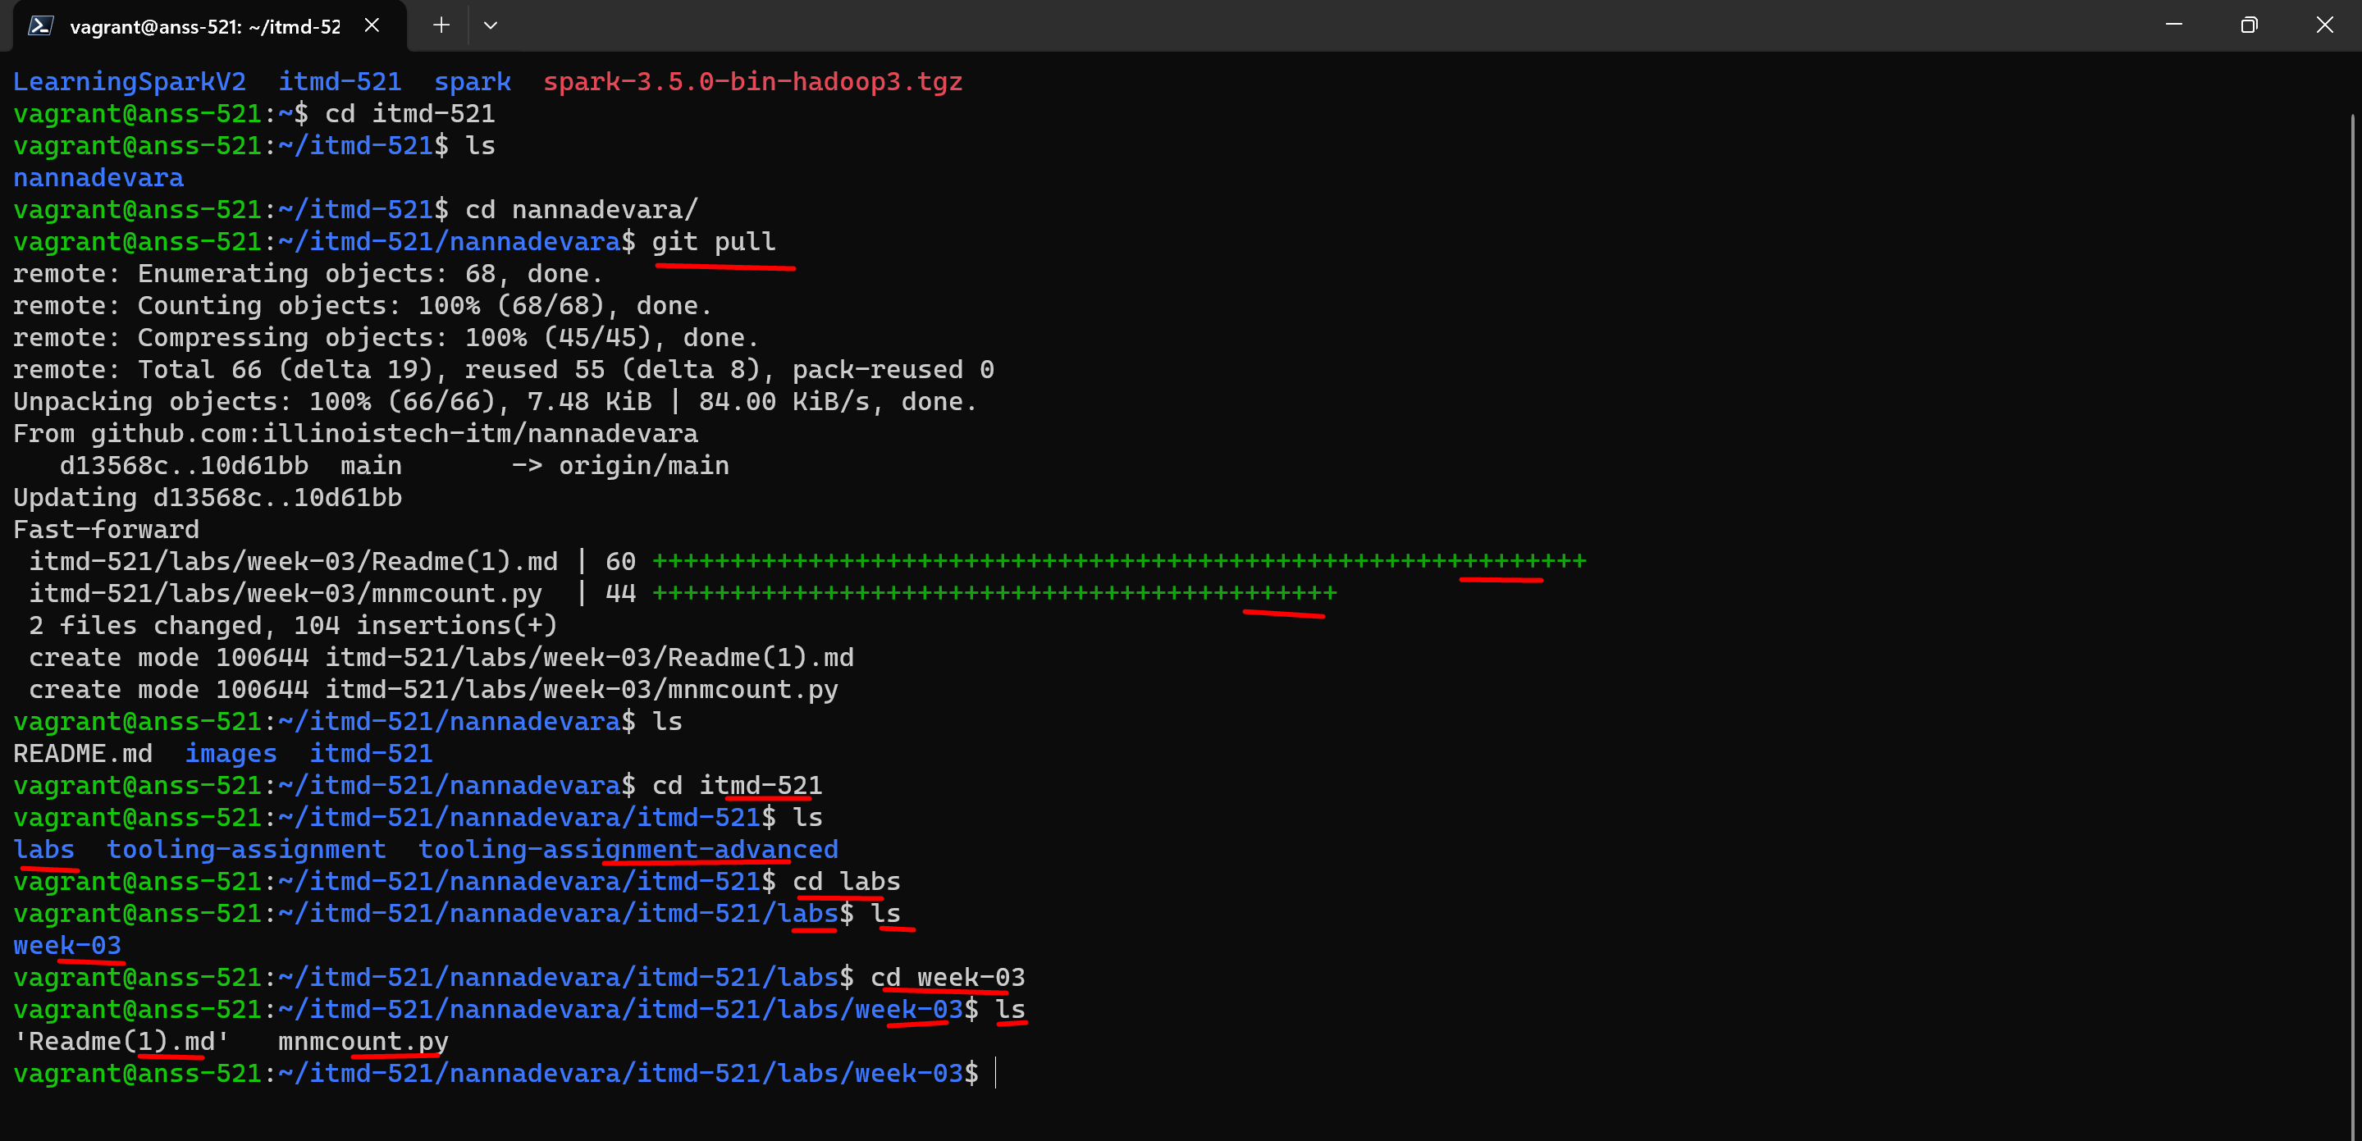

Lets run python code(python application) for mnm in this week-03 directory with spark submit command:

**spark-submit mnmcount.py ~/LearningSparkV2/chapter2/py/src/data/mnm_dataset.csv**

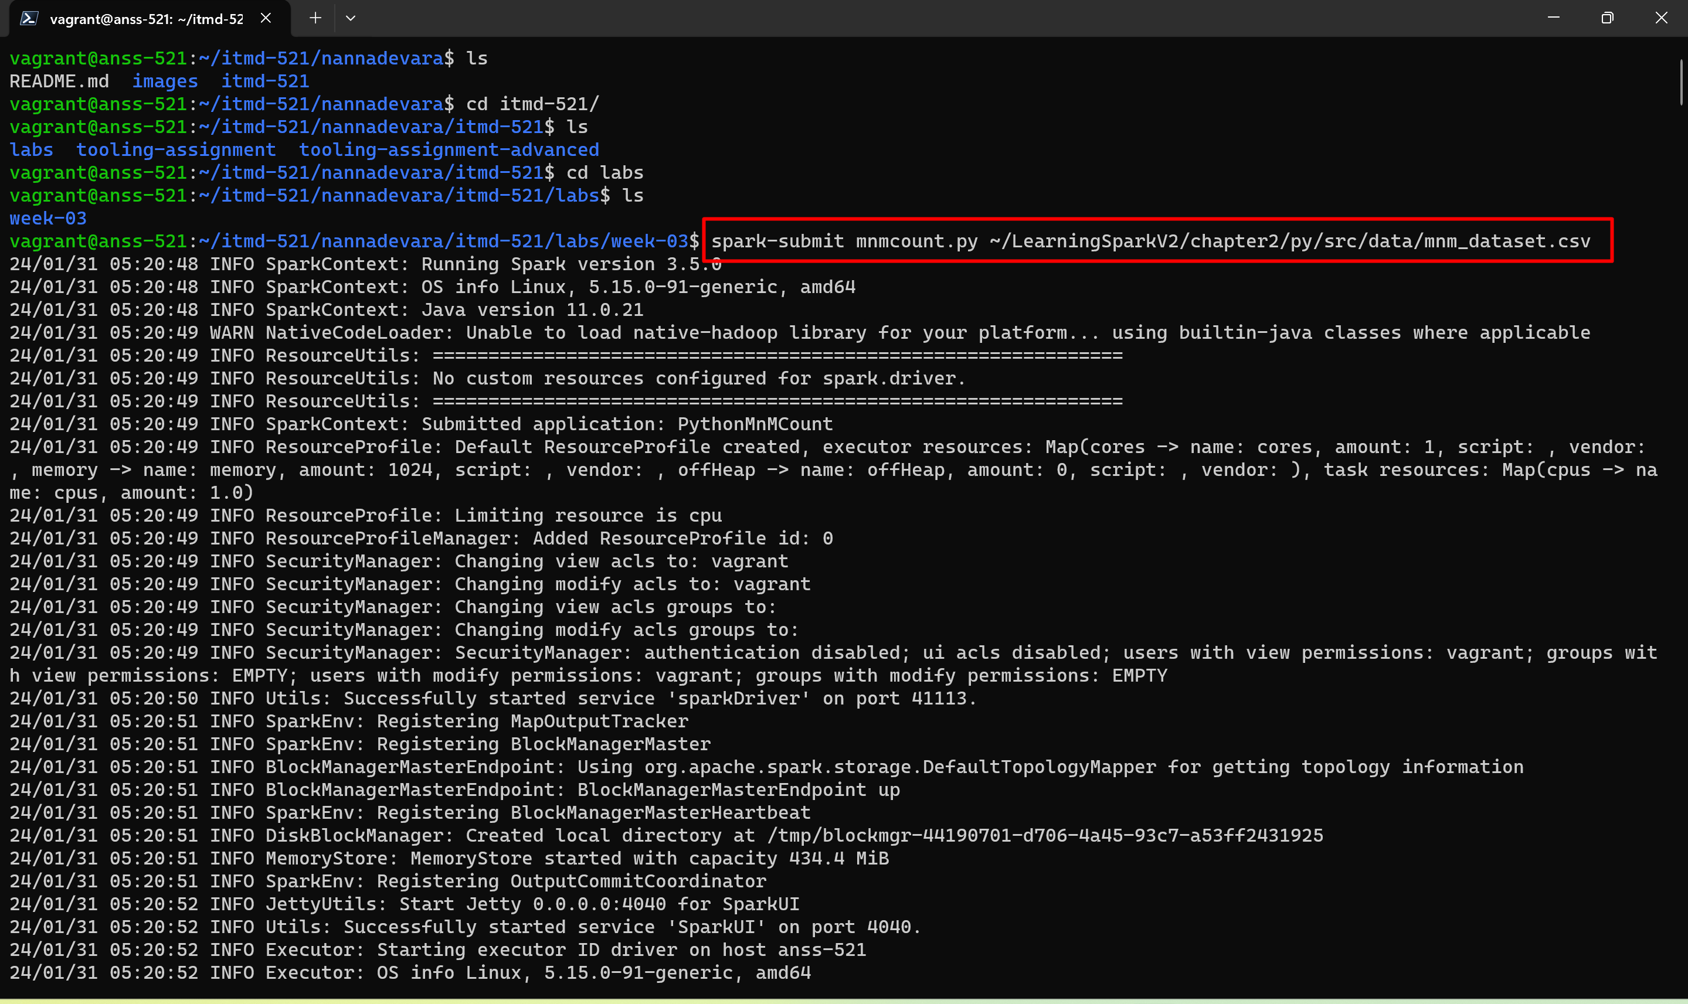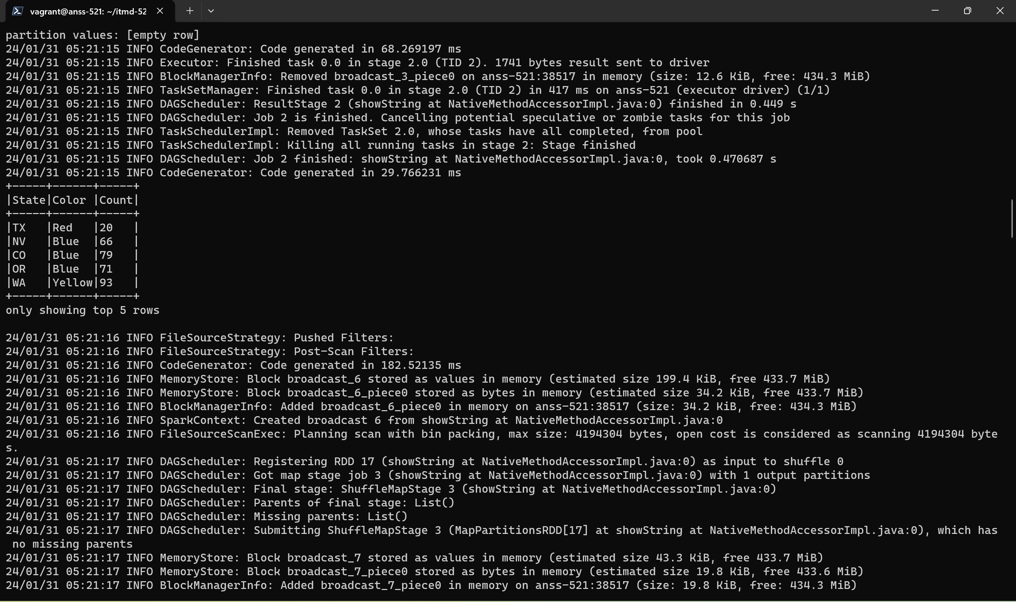

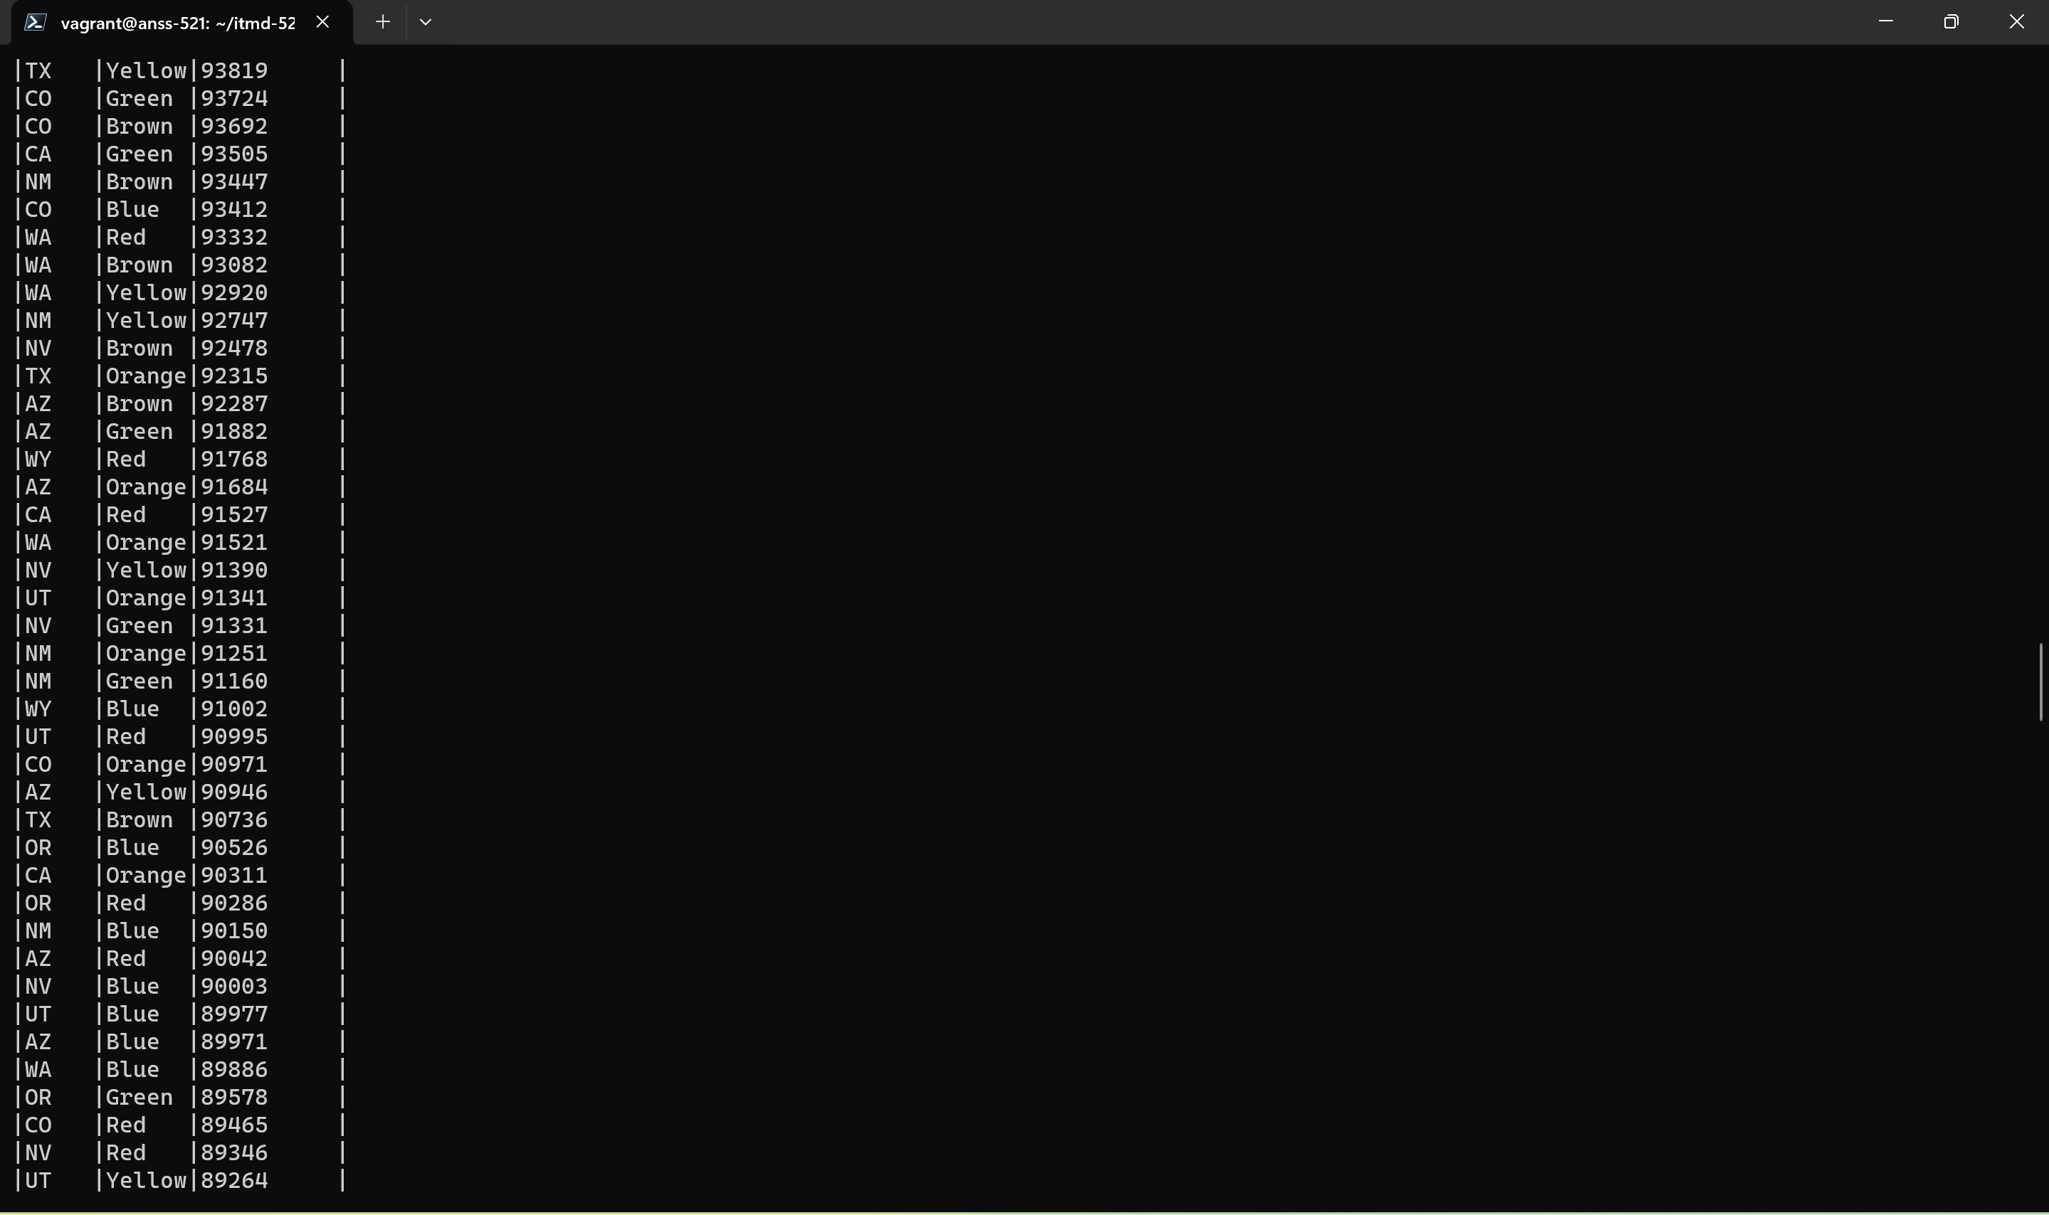

**This Is the final screenshot we want to paste in the readme.md**

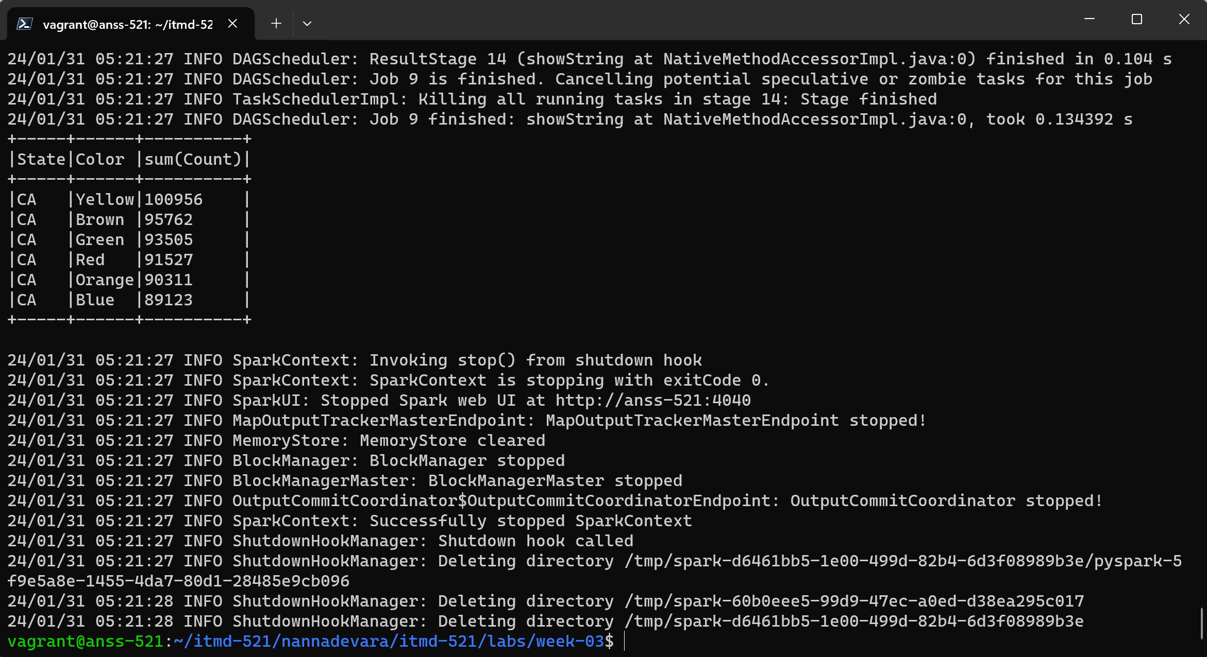

**For scala version:**

we need to install sbt in home vagrant with the commands: **(ONE AFTER ONE), and build sbt in our scala directory to generate the jar file**

**INSTALL SBT:**

**sudo apt-get update**

**sudo apt-get install apt-transport-https curl gnupg -yqq**

**echo "deb https://repo.scala-sbt.org/scalasbt/debian all main" | sudo tee /etc/apt/sources.list.d/sbt.list**

**echo "deb https://repo.scala-sbt.org/scalasbt/debian /" | sudo tee /etc/apt/sources.list.d/sbt_old.list**

**curl -sL "https://keyserver.ubuntu.com/pks/lookup?op=get&search=0x2EE0EA64E40A89B84B2DF73499E82A75642AC823" | sudo -H gpg --no-default-keyring --keyring gnupg-ring:/etc/apt/trusted.gpg.d/scalasbt-release.gpg –import**

**sudo chmod 644 /etc/apt/trusted.gpg.d/scalasbt-release.gpg**

**sudo apt-get update**

**sudo apt-get install sbt**

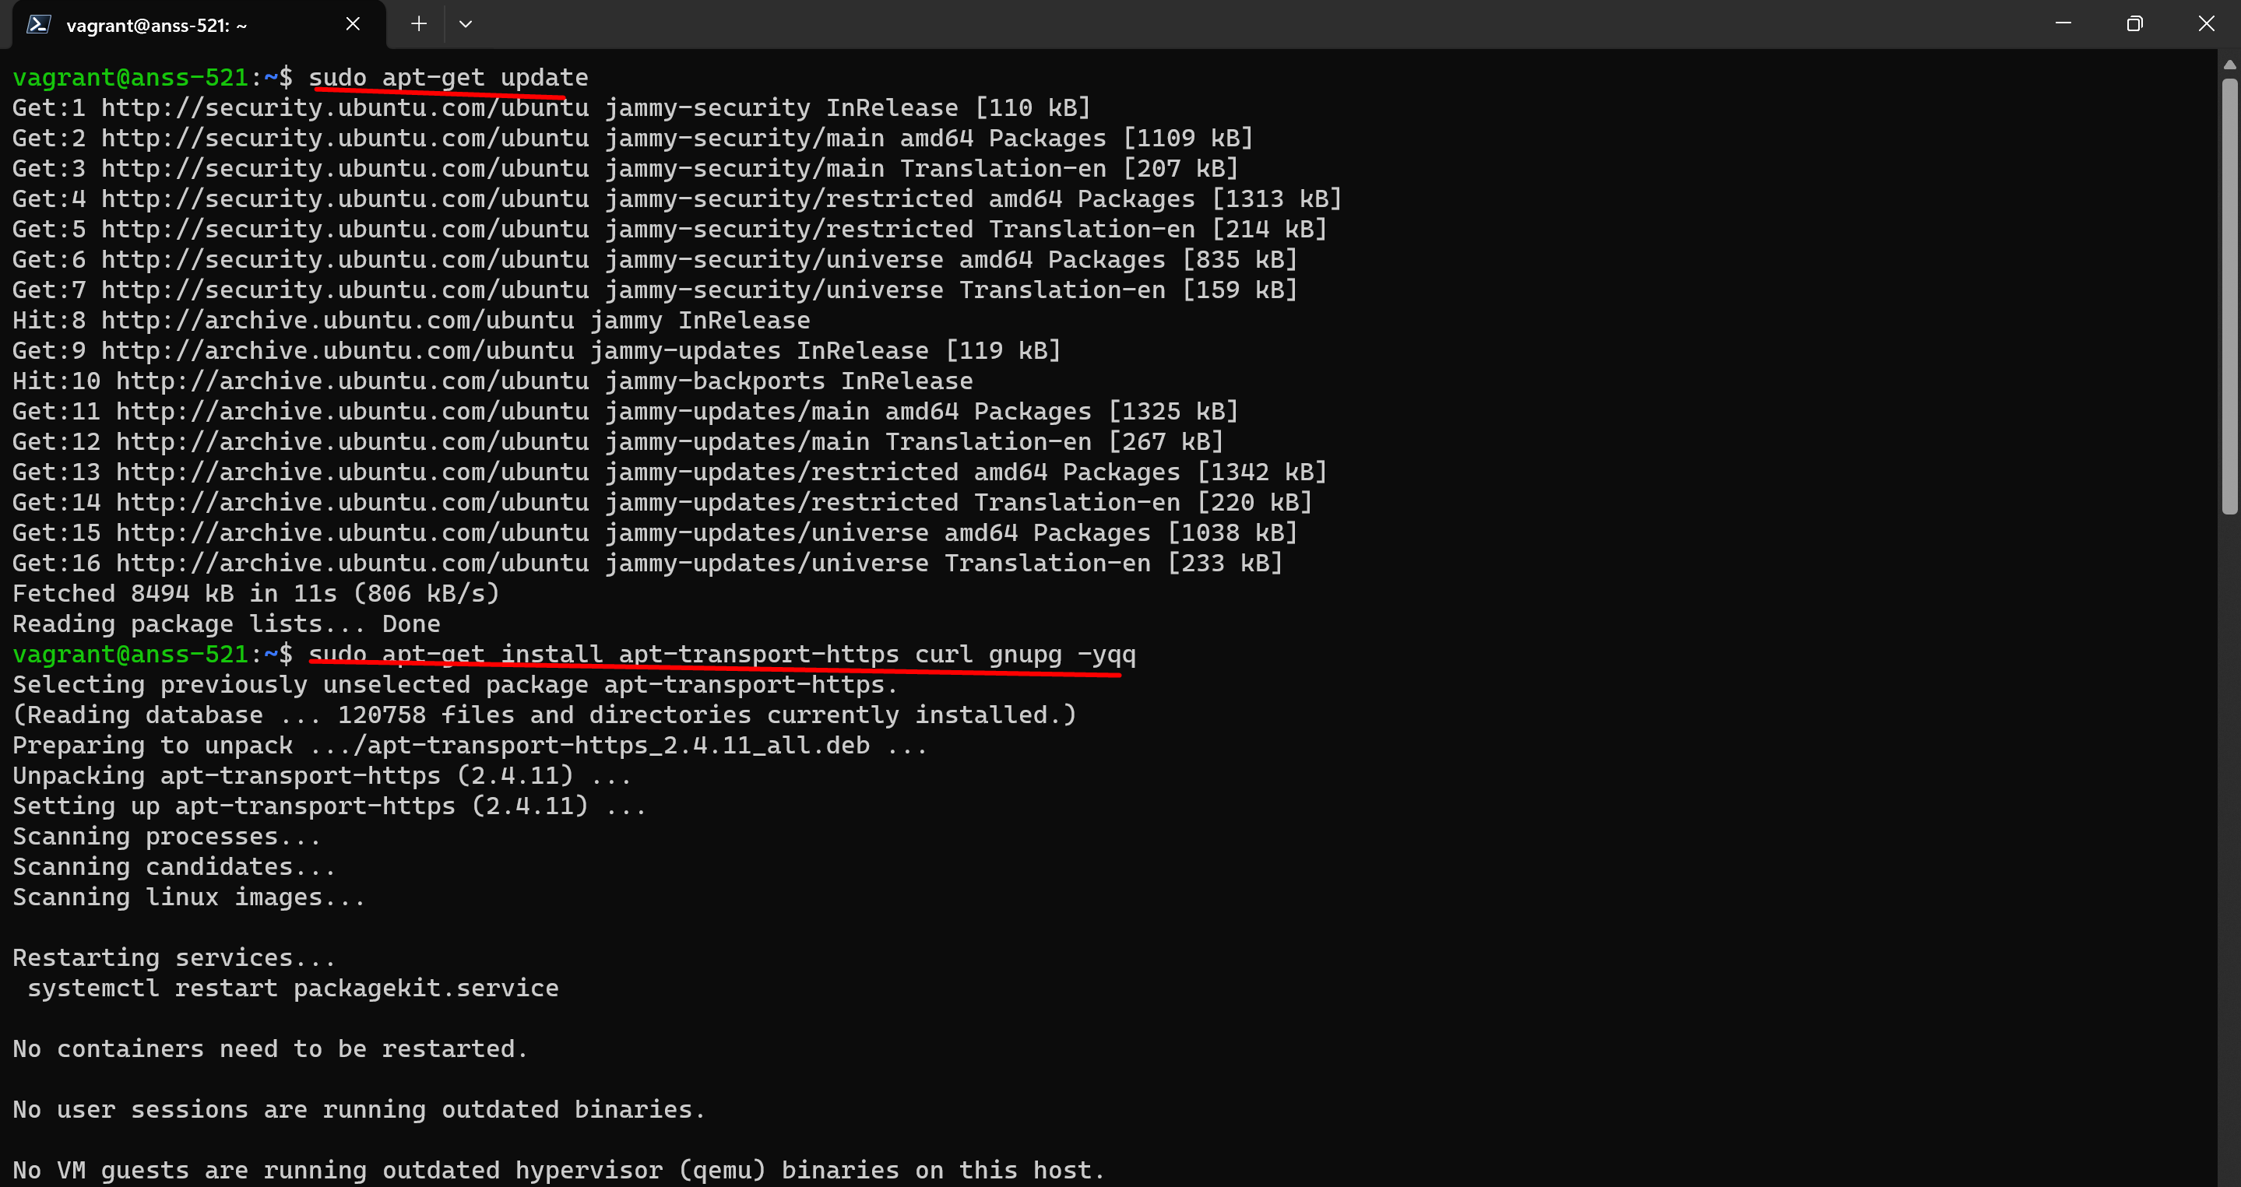

Then after the 2nd step I got this and clicked ok and proceeded to 3rd step

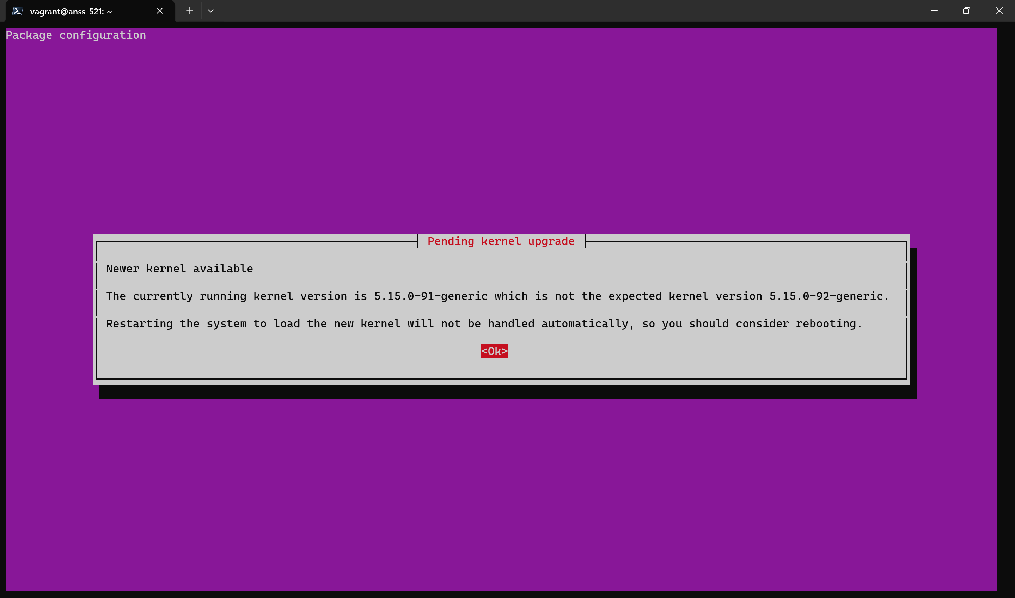

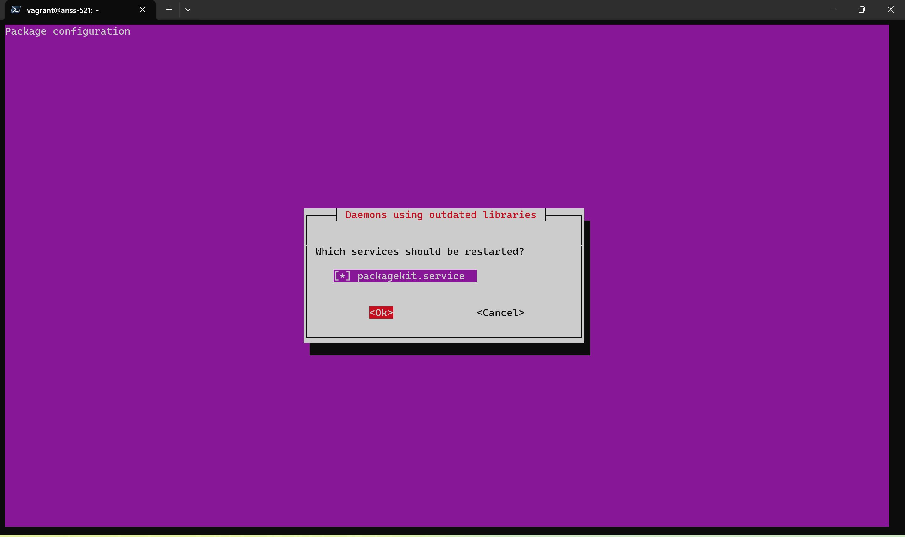

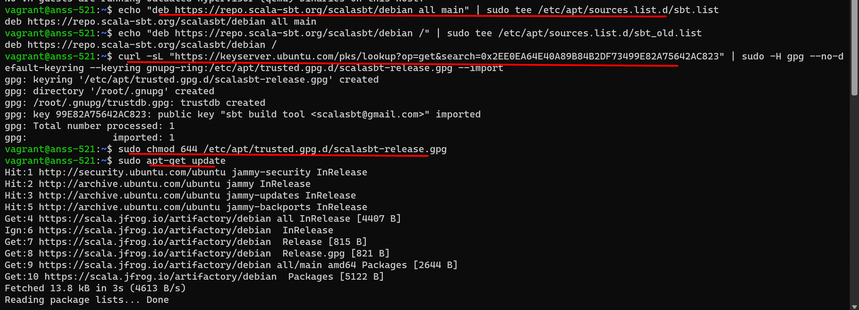

Now the last step of the code:

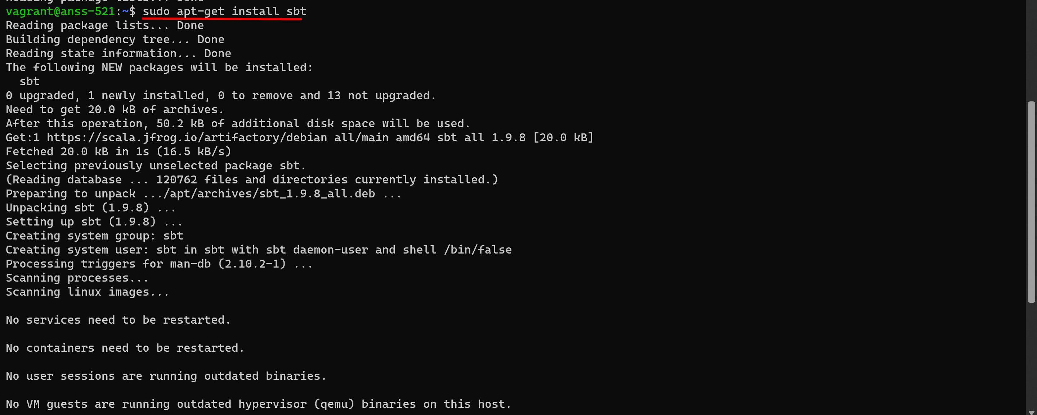

For the last step I got this.. I clicked ok.

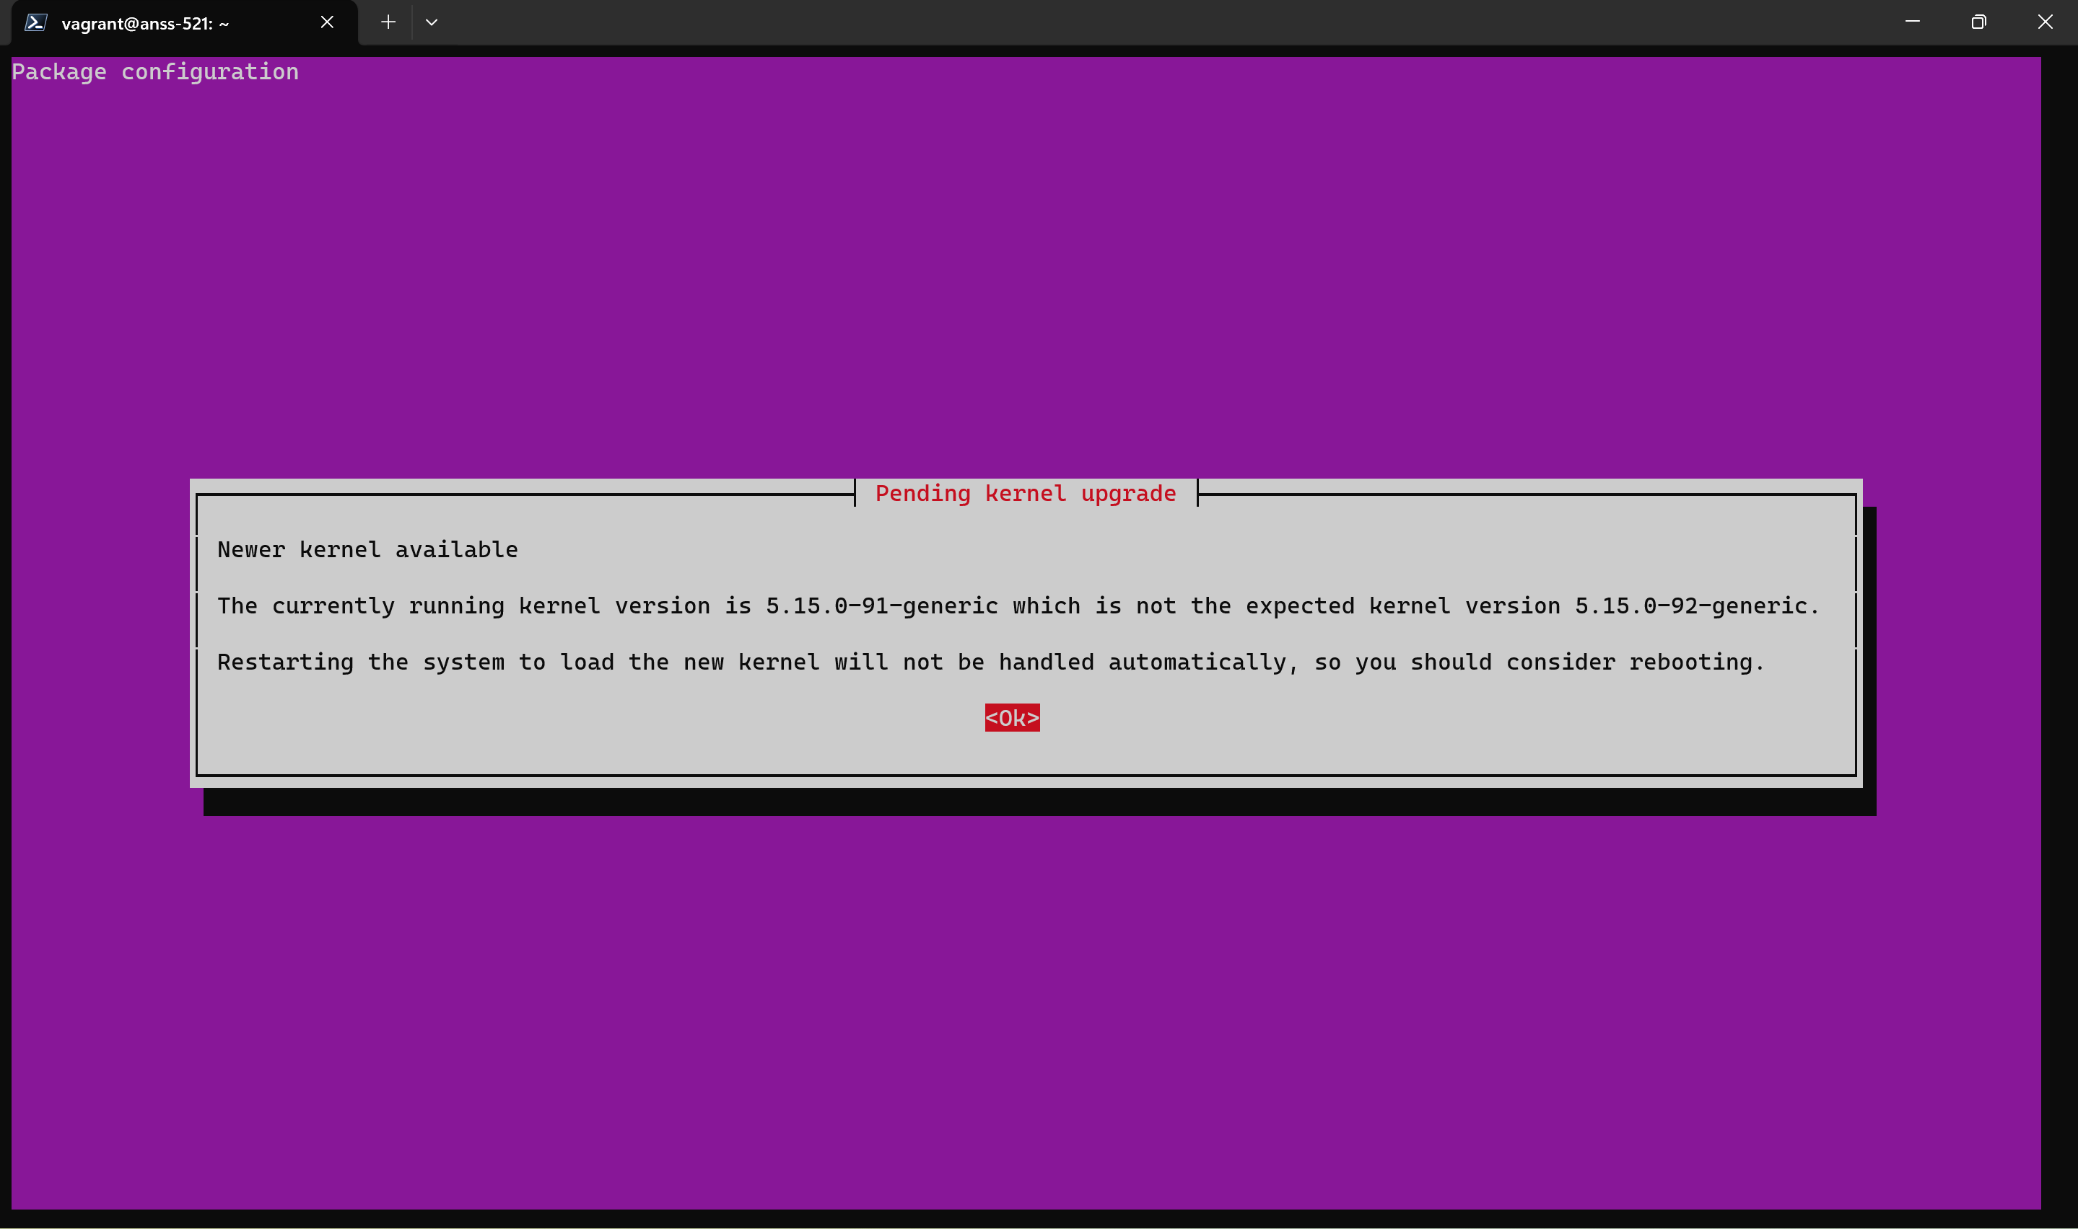

Now I typed sbt and sbt command got opened

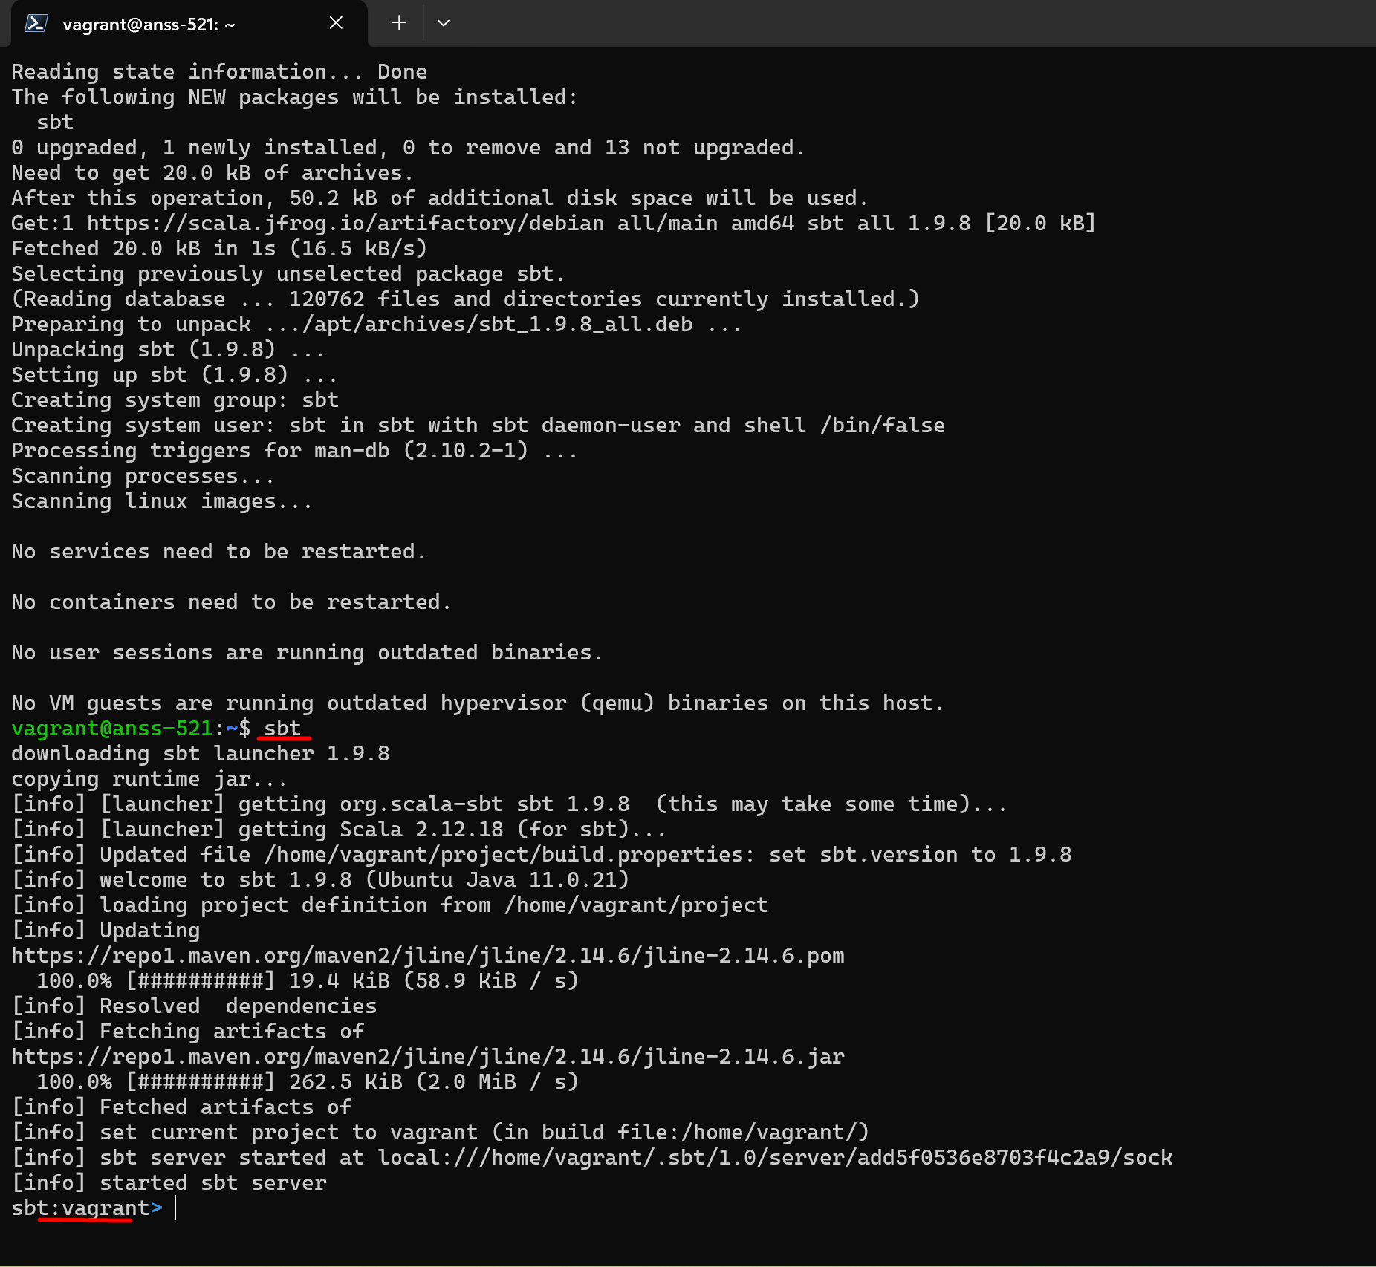



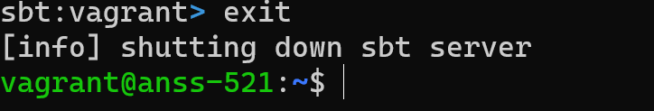

I exit the sbt and just did ls in my home vagrant box and then I got to see the target folder was created after installing sbt

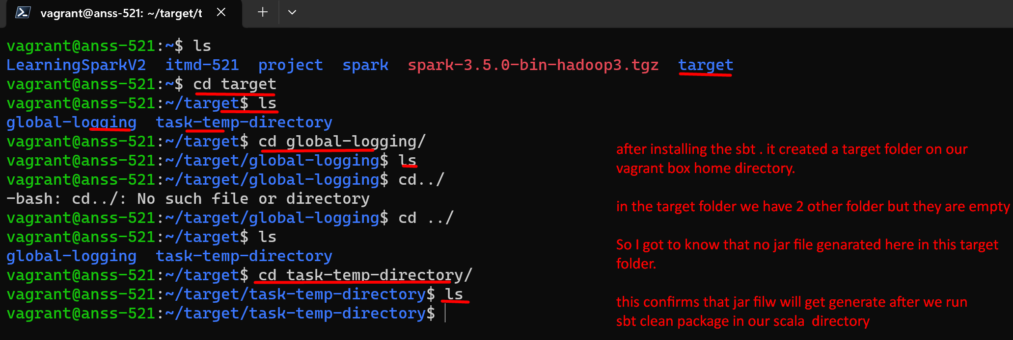

**BUILD SBT:**

After we are done with installing now we need to build sbt with the command : in our vscode scala directory where we keep build.sbt file.

**sbt clean package**

**I created a scala folder in github under itmd-521-labs-week-03 and created a build.sbt file under scala and filled it with prof’s build.sbt code.**

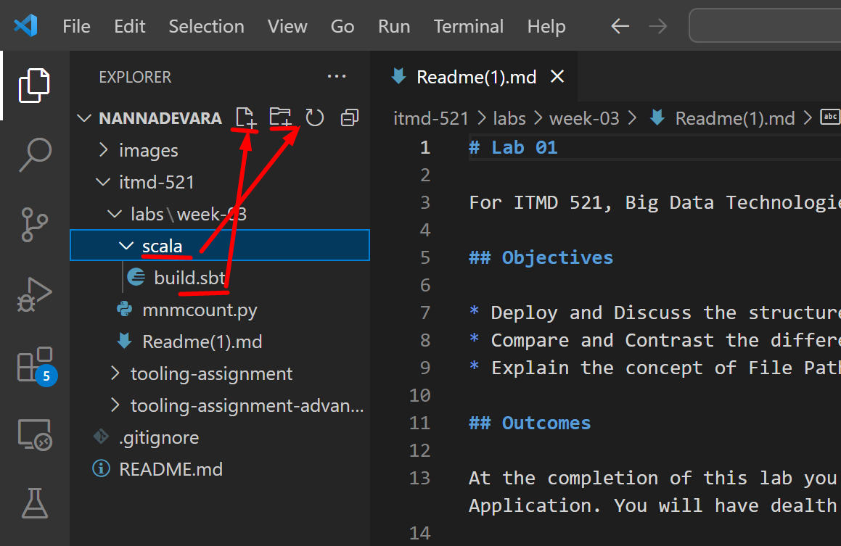

**And then I refreshed my github..reflected there these 2 things**

**And did git pull In vagrant git repo to pull these 2 things.**

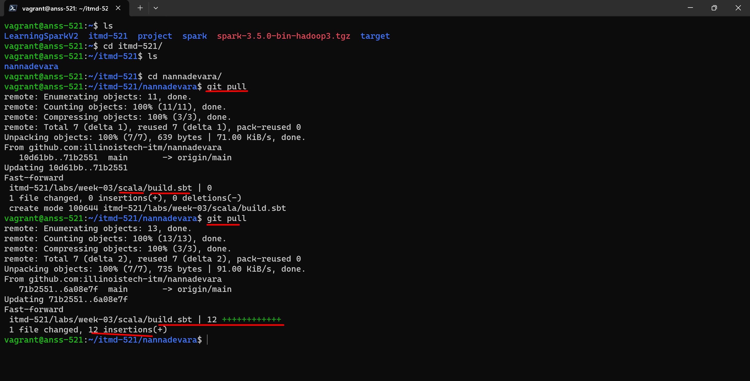

Now lets go to scala directory in our vagrant box git repo to build the sbt with the command:

**sbt clean package**

**lets go to scala directory in our repo**

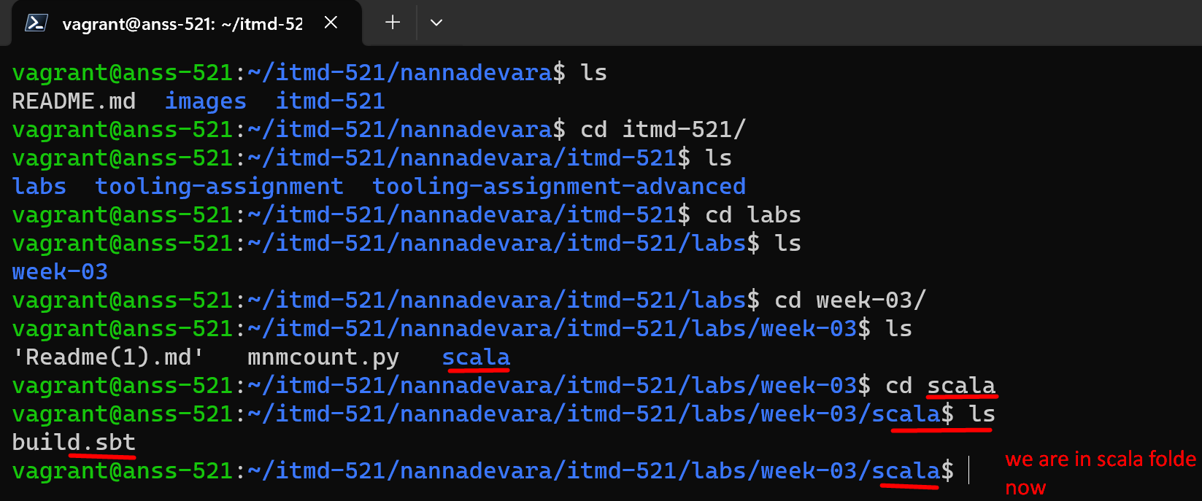

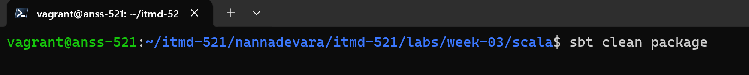

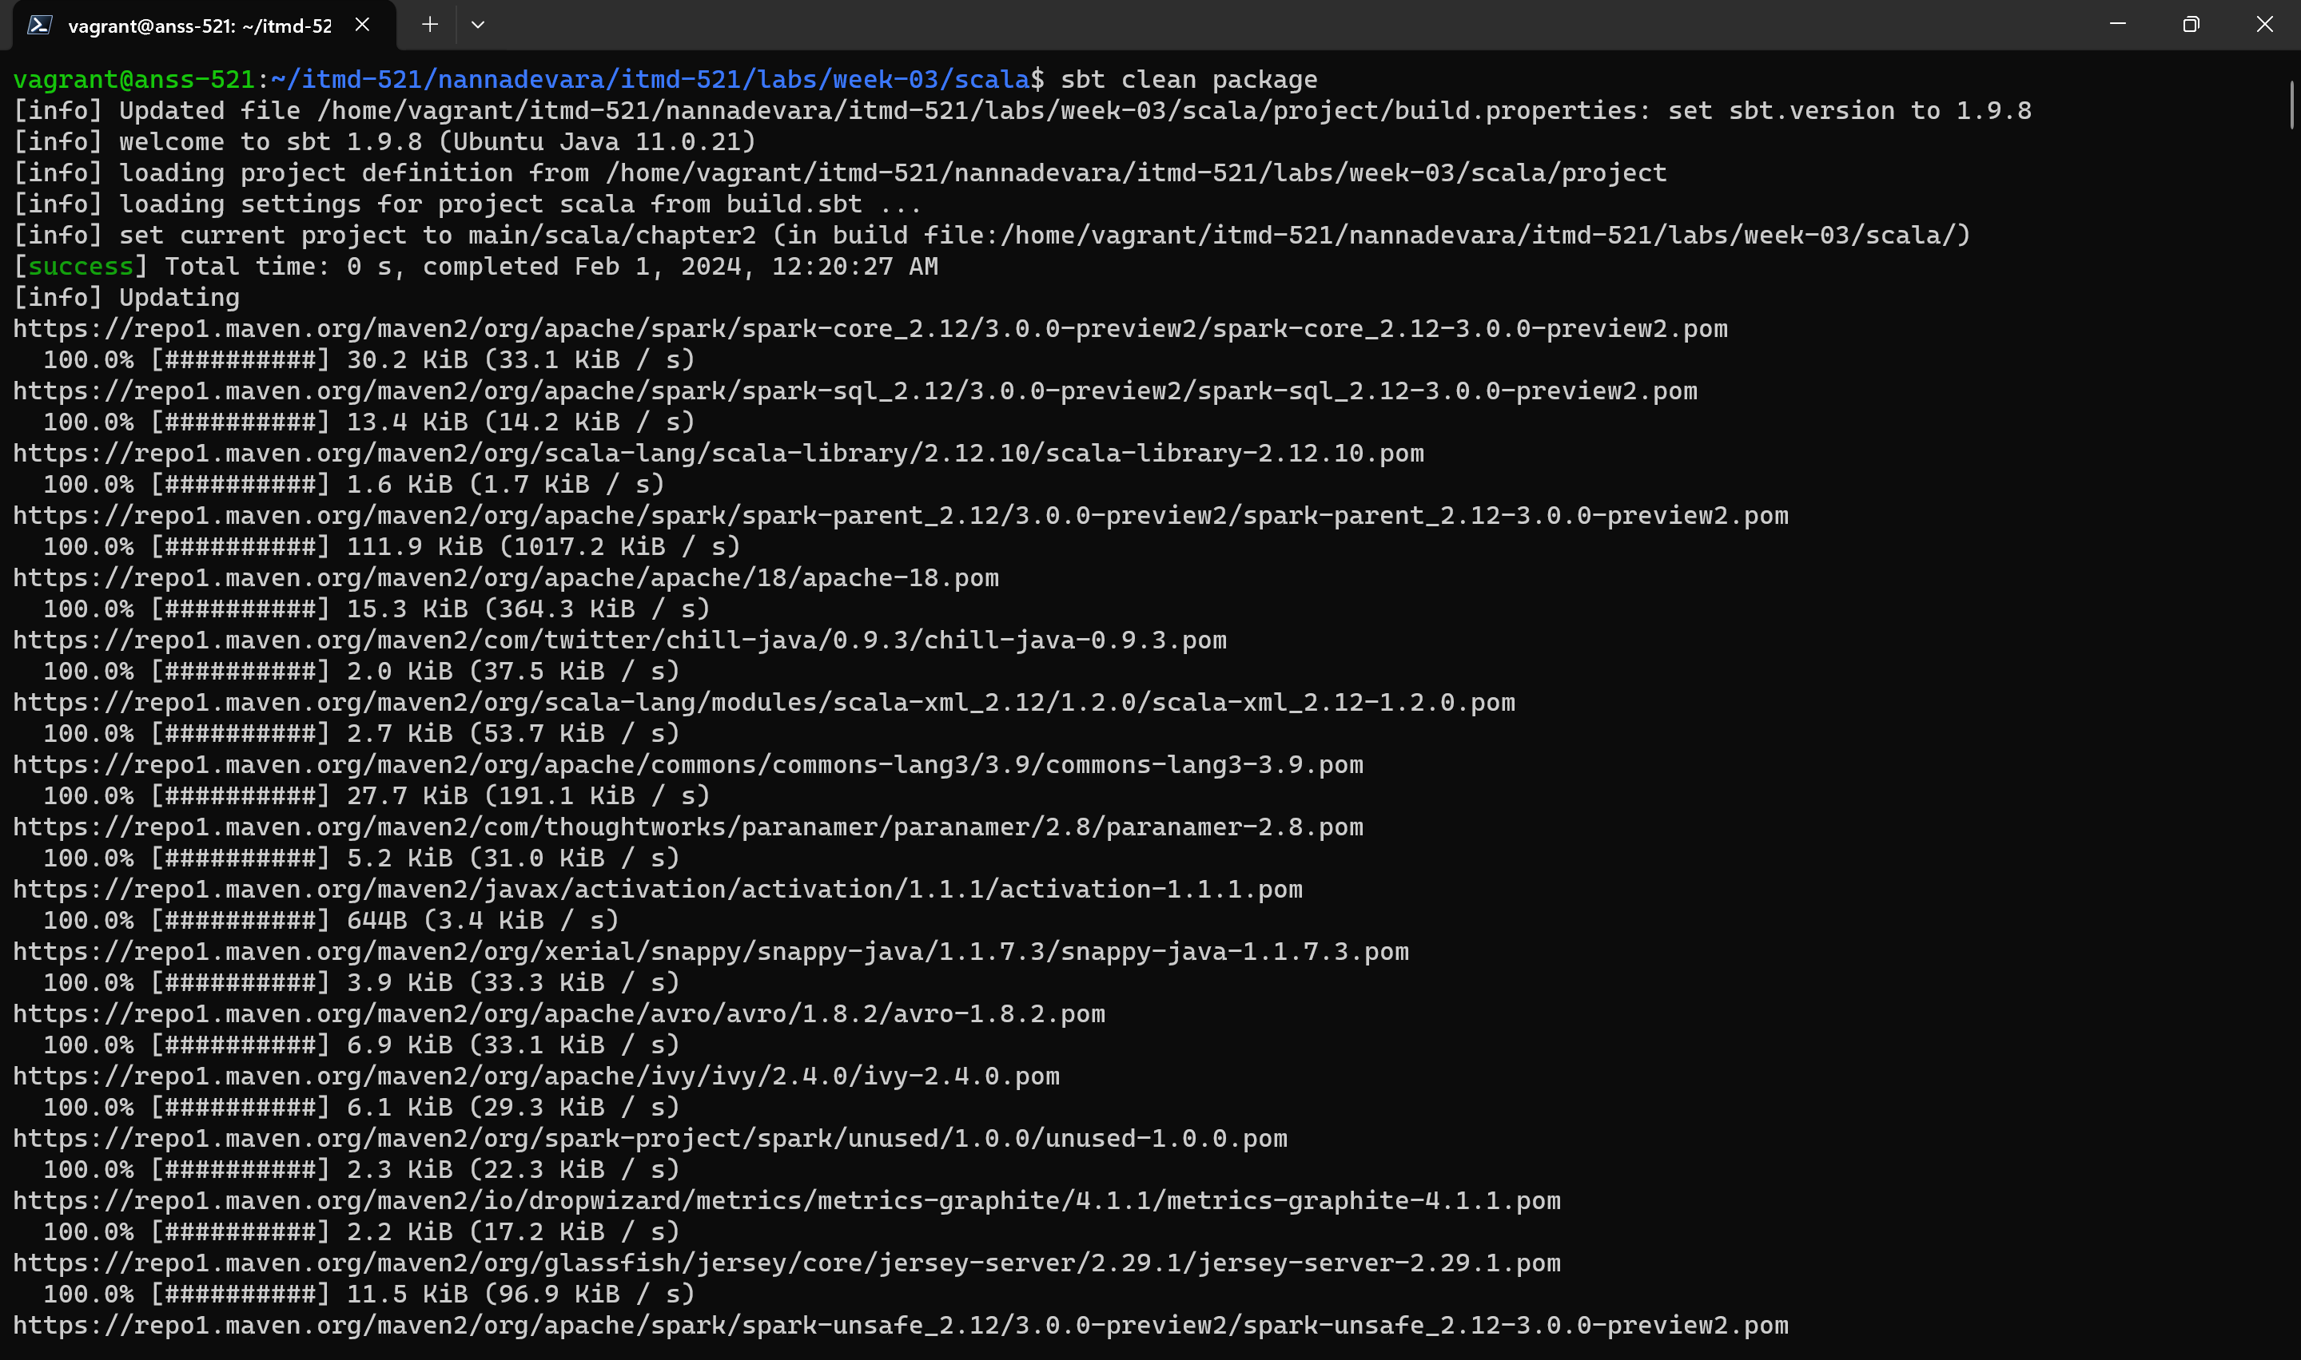

**Very long output**

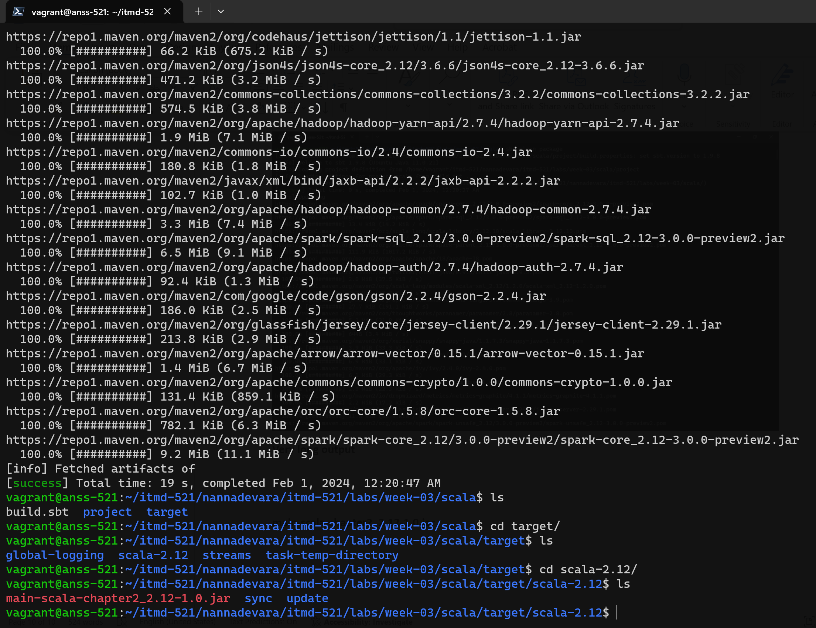

**Here is our jar file got generated in my scala/target directory.**

**main-scala-chapter2_2.12-1.0.jar**

**now lets mirror the hierarchy of thr prof scala directory ~ this is prof’s we need to create the same path in our github repo in vs code.**

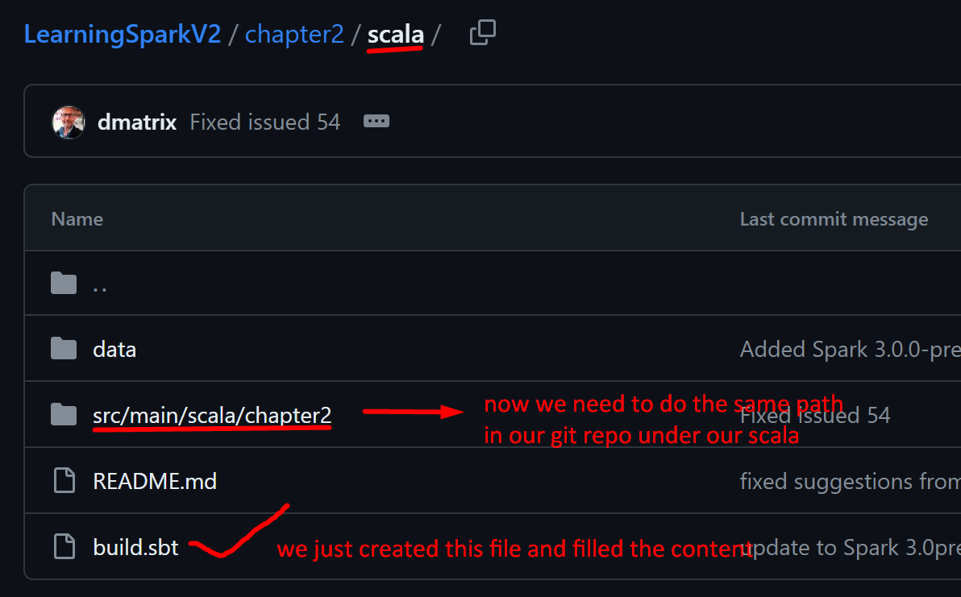

**Lets create the path in our vs code:**

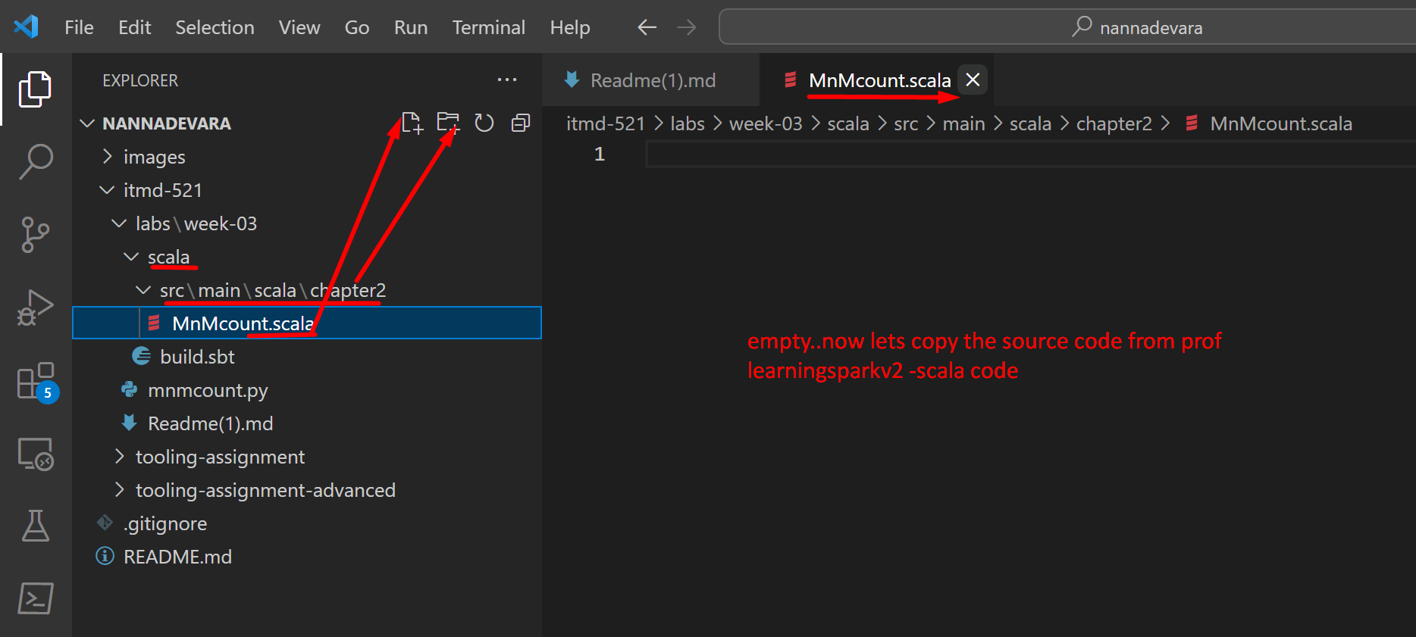

**Refreshed in my github**

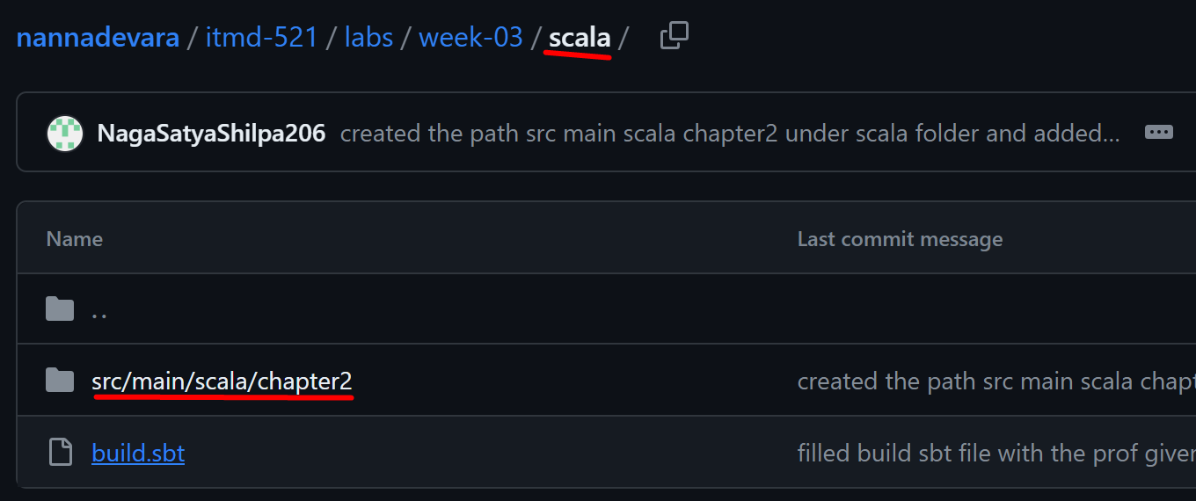

**Did the git pull from nannadevara**

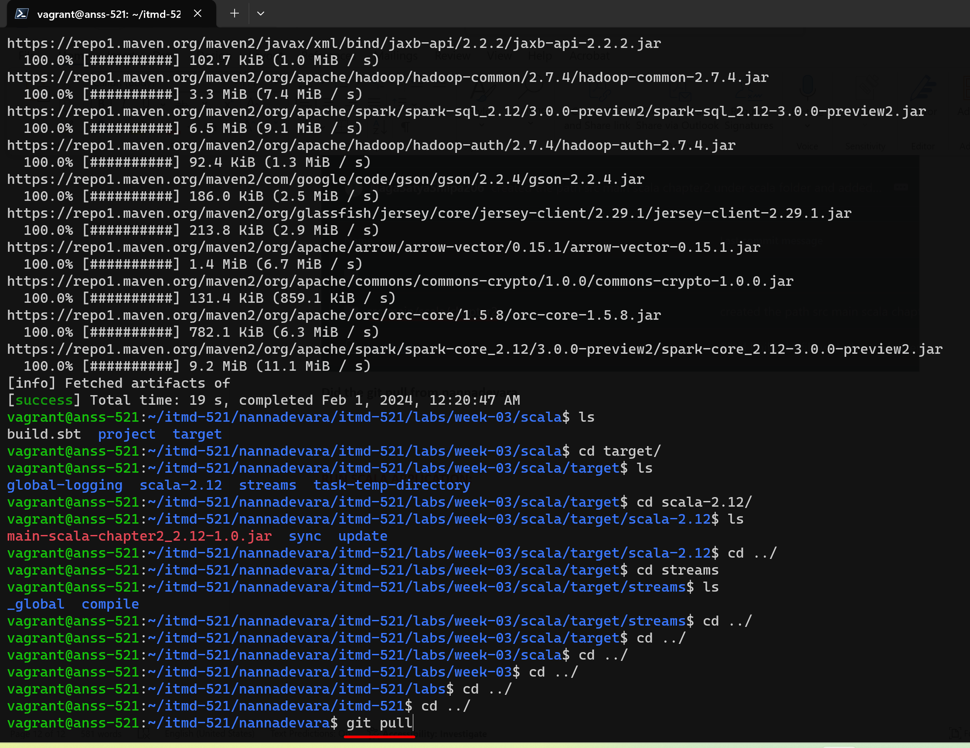

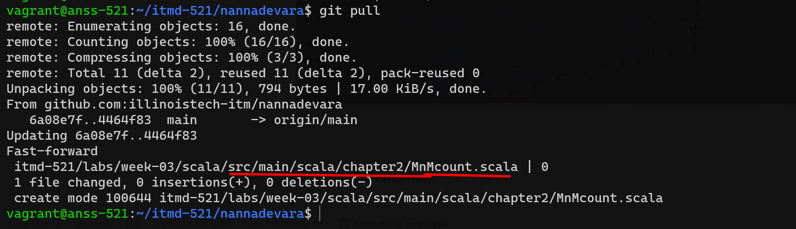

**Now lets fill the MnMcount.scala file in our vs code**

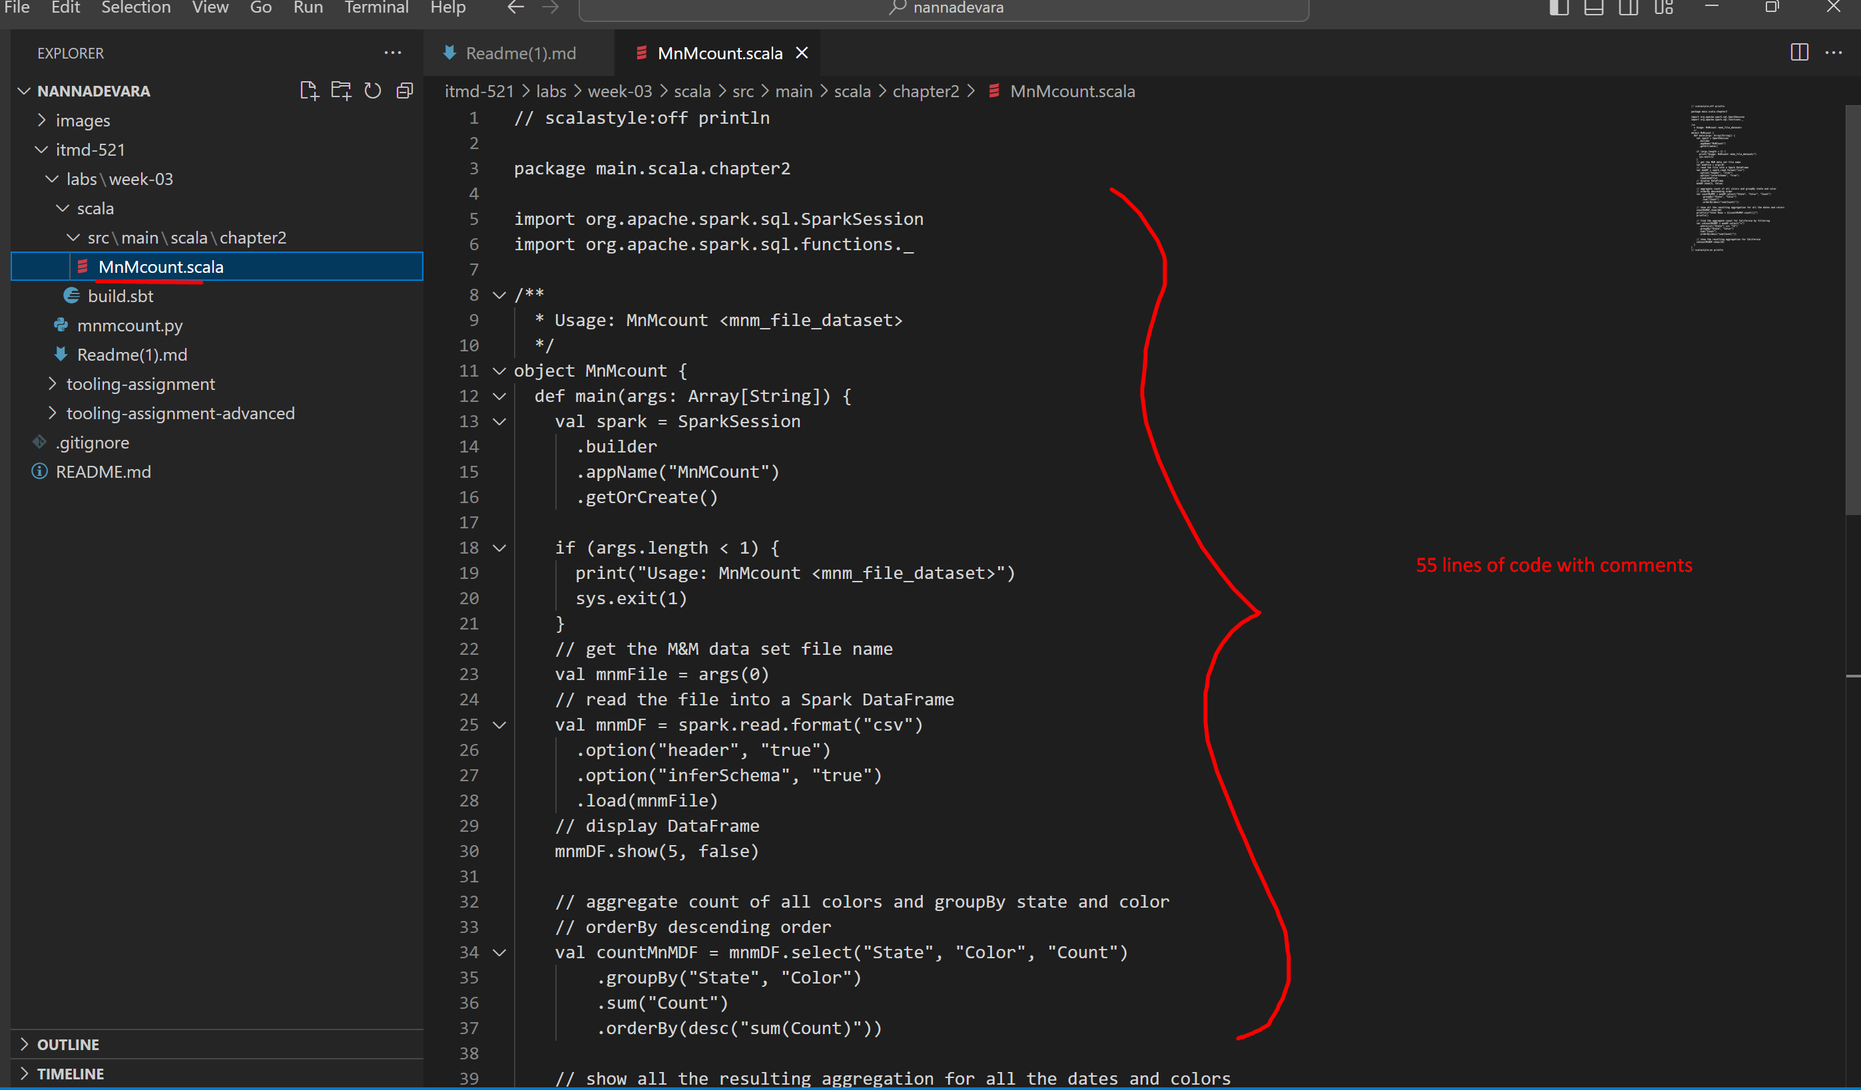

**Refreshed in mygithub**

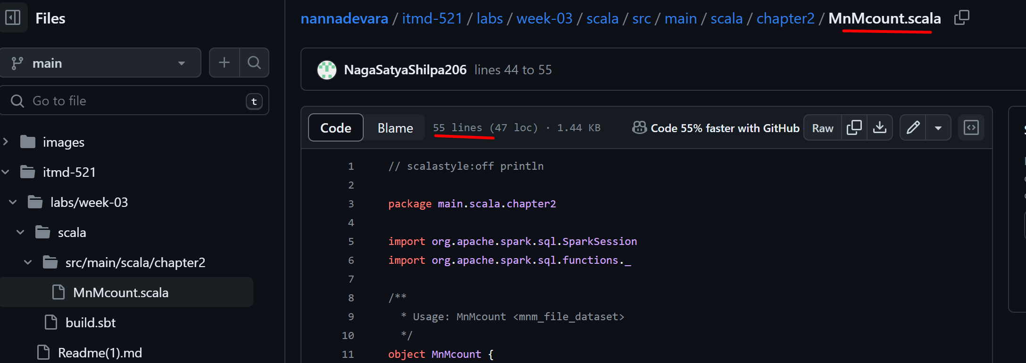

**Did the git pull from nannadevara in vagrant box to update the changes**

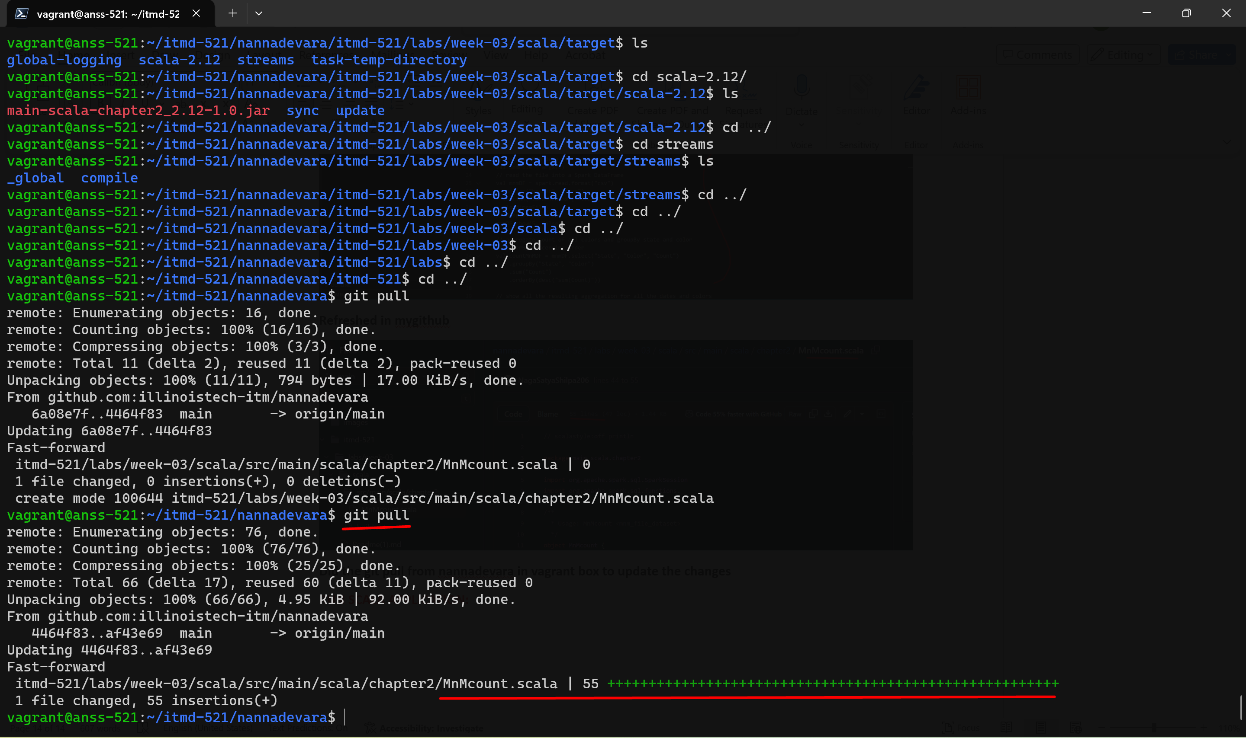

**RUN SCALA APPLICATION:**

**Now lets run the scala application with the command:**

**spark-submit --class main.scala.chapter2.MnMcount ~/itmd-521/nannadevara/itmd-521/labs/week-03/scala/target/scala-2.12/main-scala-chapter2_2.12-1.0.jar ~/LearningSparkV2/chapter2/py/src/data/mnm_dataset.csv**

**lets to to ~~~~~ our scala/src/main/scala/chapter2 in our vagrant box git repo**

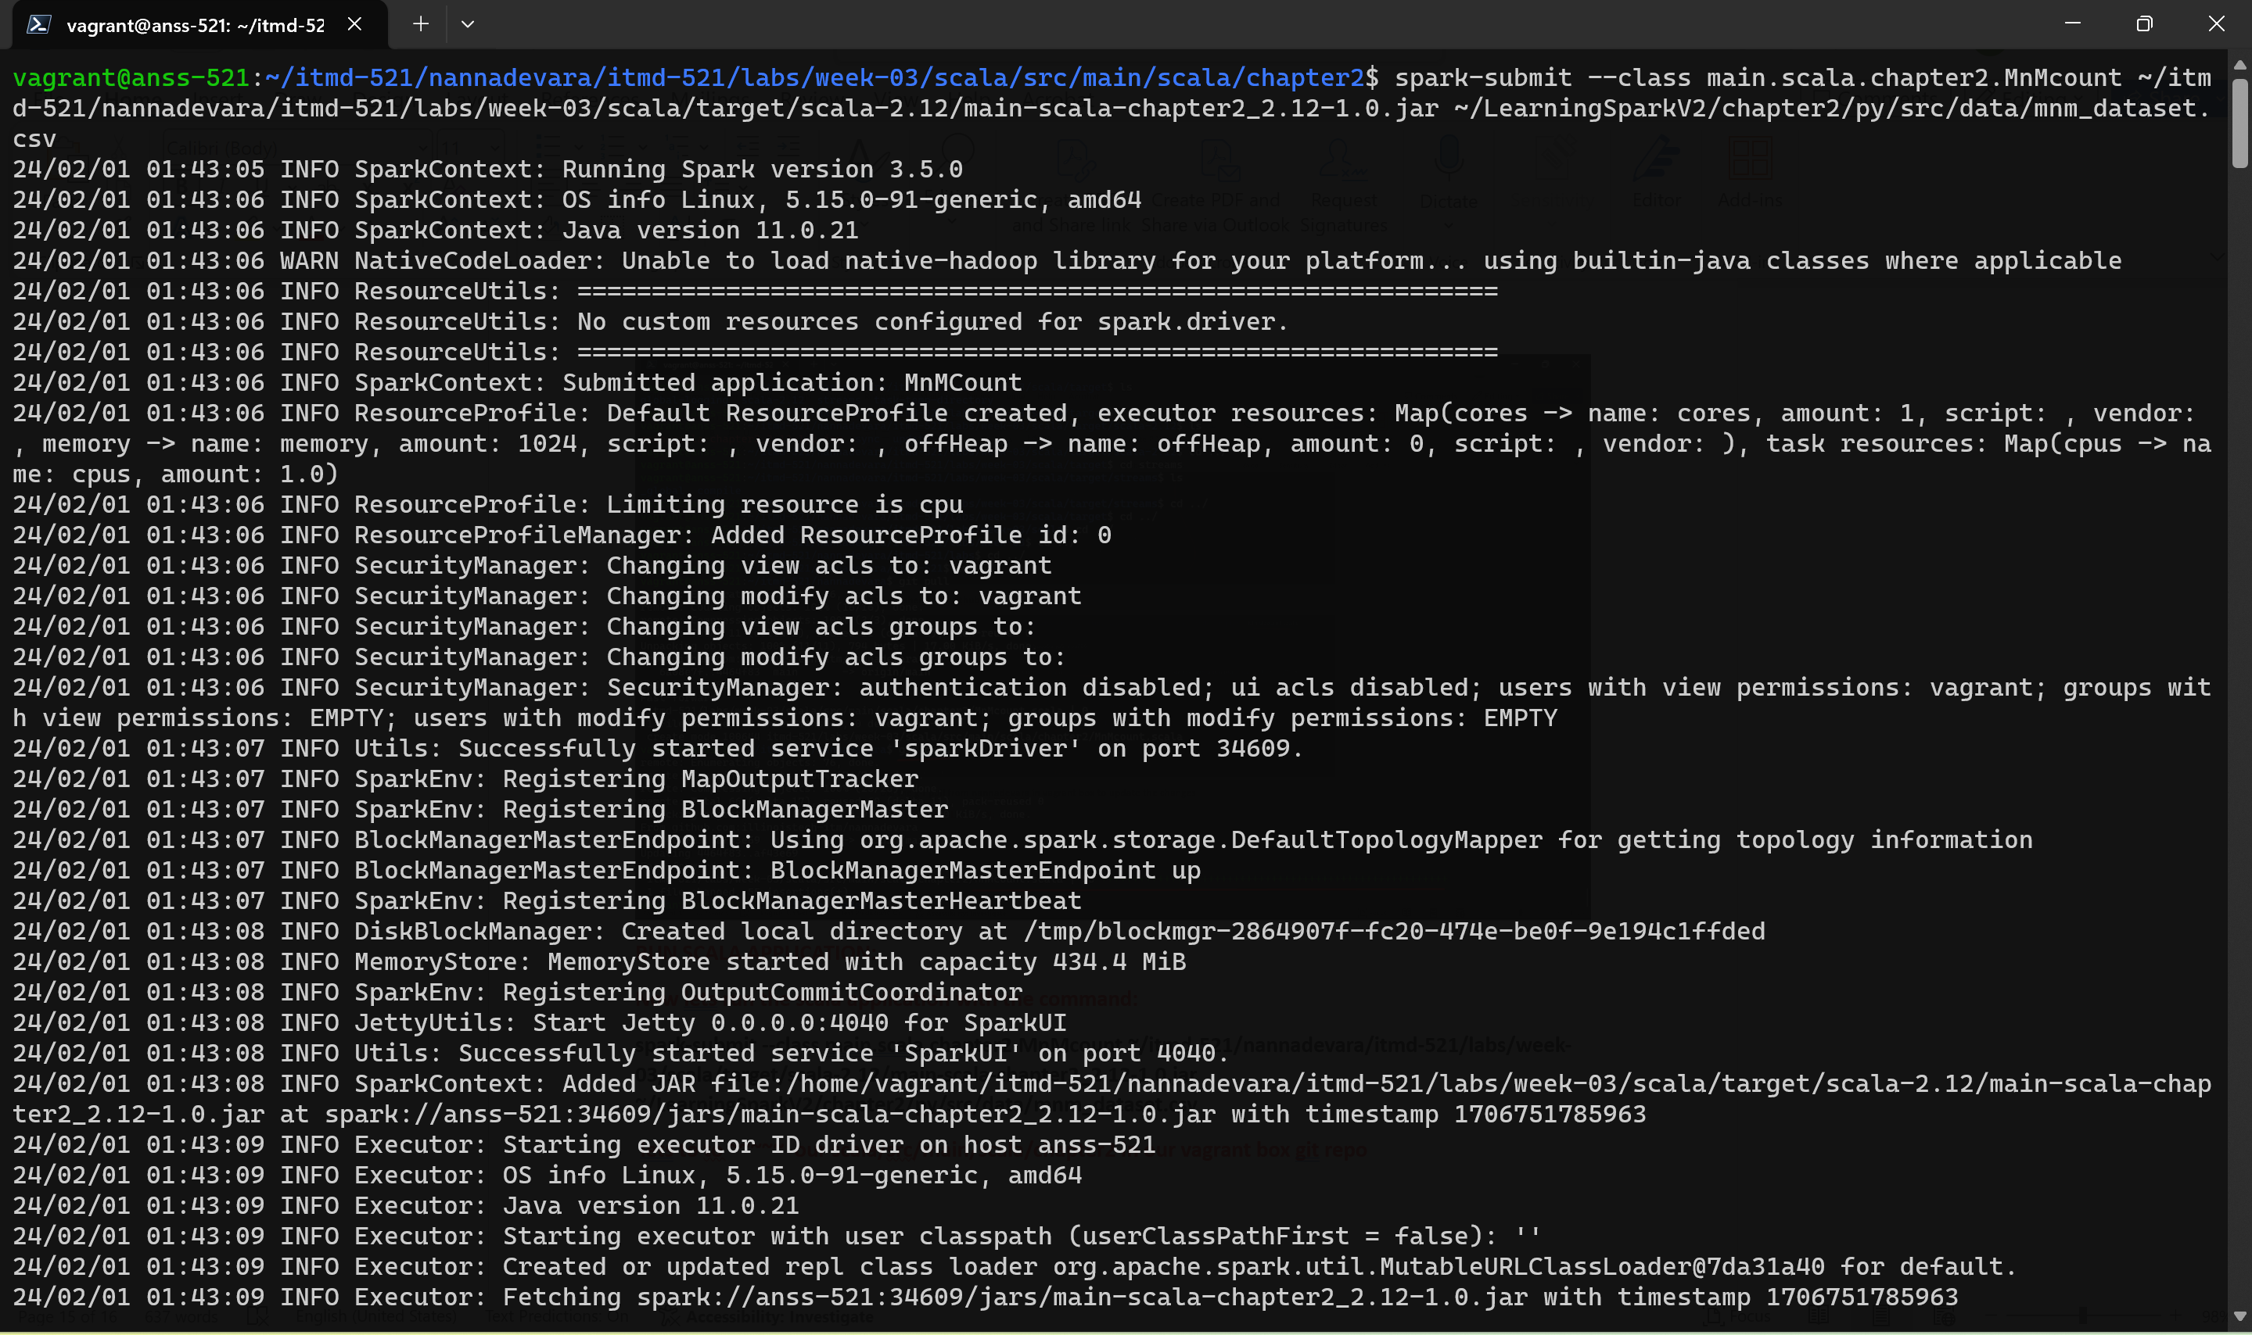

**Long output in the middle**

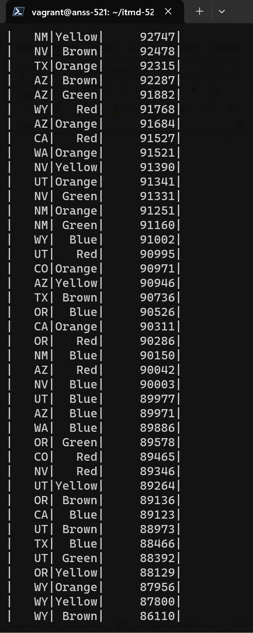

**Our final output in the end:**

**SPARK SUBMIT OUTPUT:**

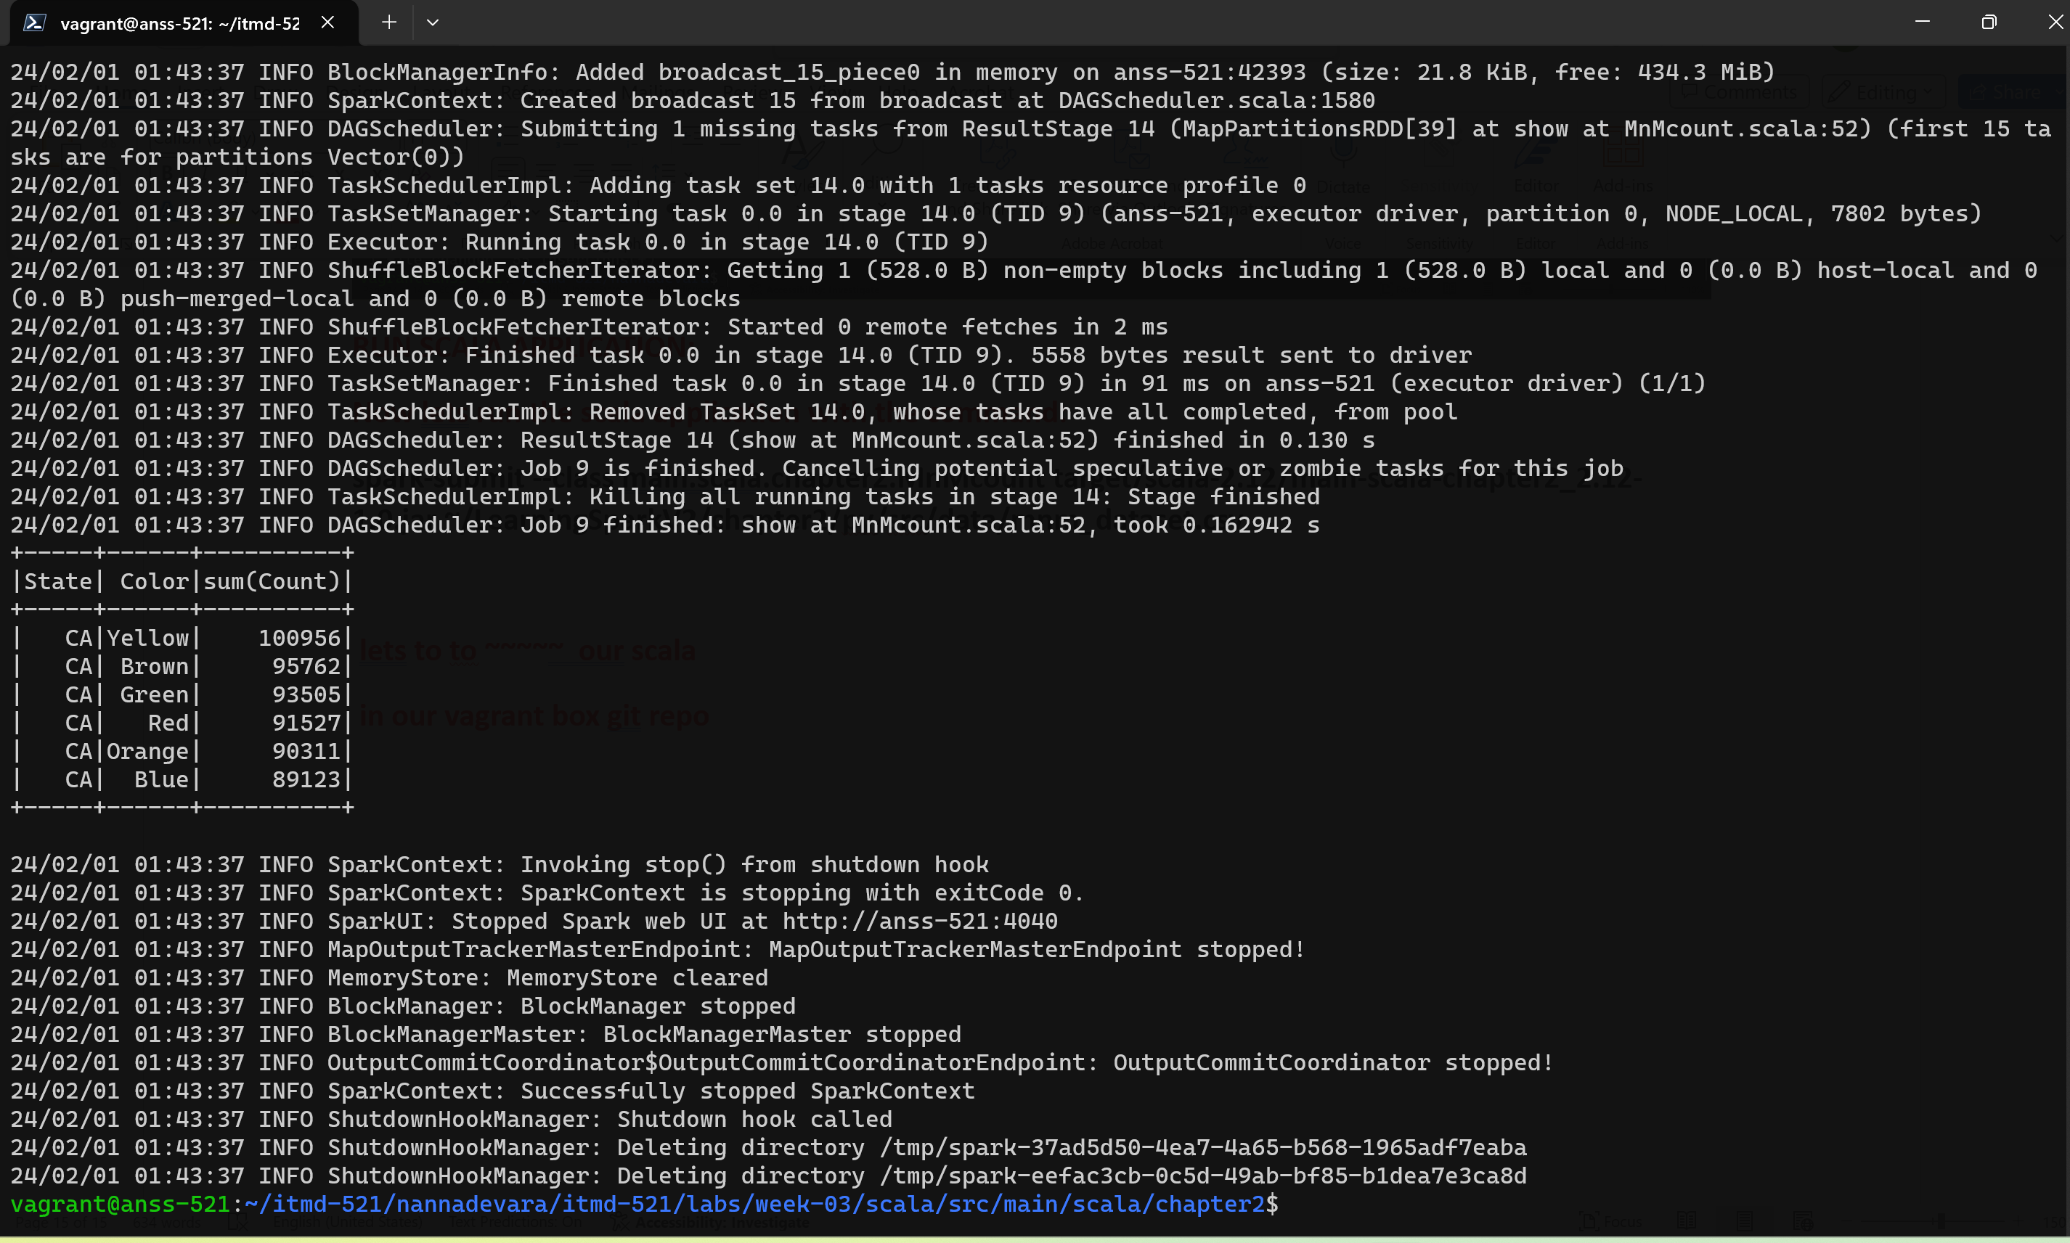

**Sbt clean package**

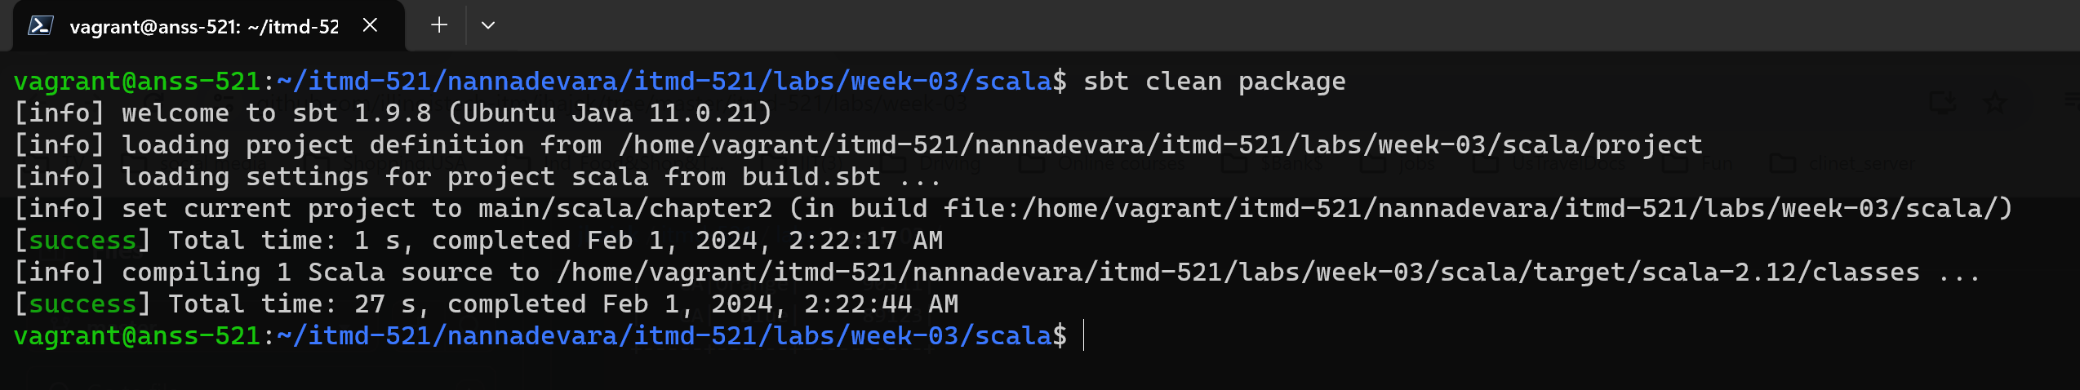

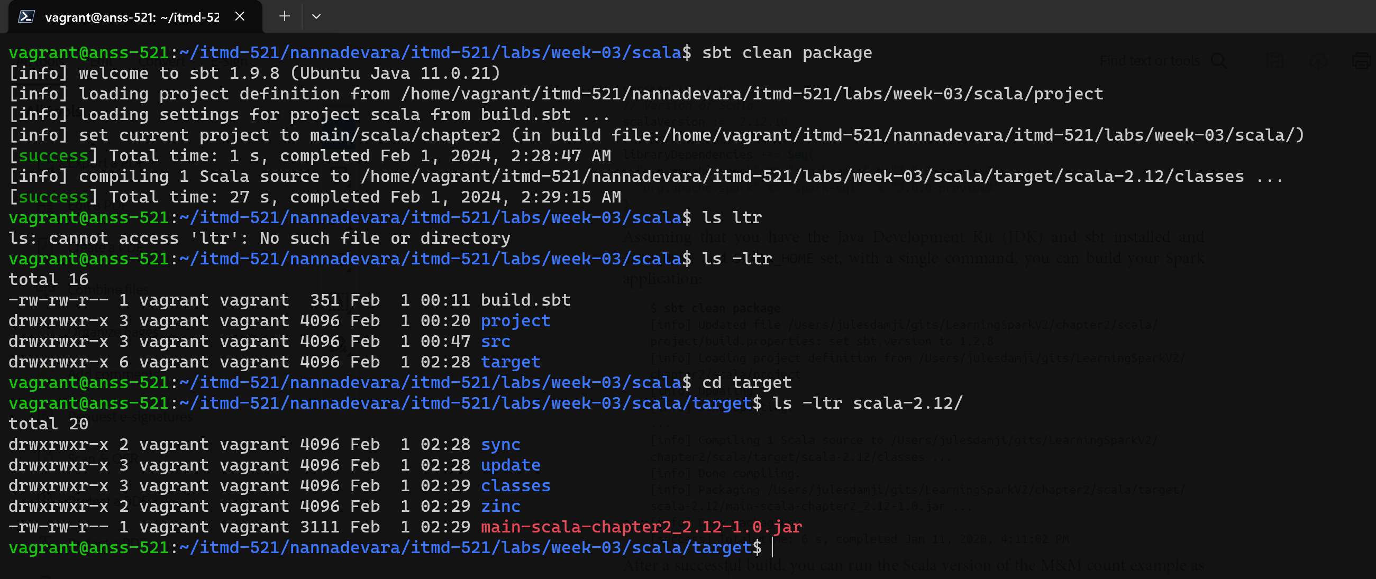

**ERROR I GOT:**

**Class not found when I ran spark submit command…**

**Bcoz I didn’t fill the MnM code and did sbt clean package**

**So this step will compile the jar file without generating the code. So the jar file size is very less(242).. the jar file didn’t compiled properly**

**Then I did again sbt clean package after filling the MnMcount.scala code then it generated the jar file again with larger size now.**

**This is the correct jar file**

**So I ran the spark submit command with this new jarfile and it worked.**

**The new jar file is updated in my doc above in the jarfile place**

**At the end I did**

